Project Description Report

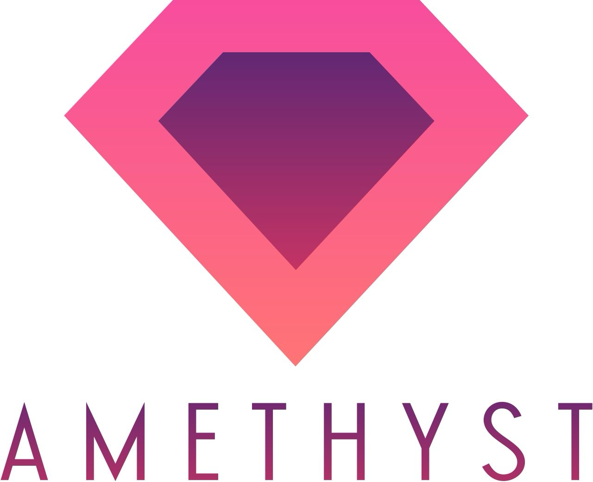

Project Amethyst
Group 22

Prepared by
Kareem Muftee, Xavier Hale, Ferdinand Lim, Alan Chen
For use in CS440 at
The University of Illinois at Chicago
Spring 2026

Table Of Contents
- Project Description 7
- Project Overview 7
- Purpose Of The Project 7
2a. The User Business Or Background of The Project Effort 7
2b. Goals Of The Project 8
2c Measurement 8
- The Scope Of The Work 9
3a. The Current Situation 9
3b. The Context Of The Work 10
3c. Work Partitioning 11
3d. Competing Products 12
- Scope Of The Product 12
4a. Scenario Diagram(s) 13
4b. Product Scenario List 13
4c. Individual Product Scenarios 14
- Stakeholders 15
5a. The Client 15
5b. The Customer 15
5c. Hands-On Users Of The Product 16
5d. Maintenance Users And Service Technicians 17
5e. Other Stakeholders 18
5f. User Participation 19
5g. Priorities Assigned To Users 19
- Mandated Constraints 20
6a. Solution Constraints 20
6b. Implementation Environment Of The Current System 21
6c. Partner Or Collaborative Applications 21
6d. Off-The-Shelf Software 22
6e. Anticipated Workplace Environment 22
6f. Schedule Constraints 23
6g. Budget Constraints 23
- Naming Conventions And Definitions 23
7a. Definitions Of Key Terms 23
7b. UML And Other Notation Used In This Document 24
7c. Data Dictionary For Any Included Models 24
- Relevant Facts And Assumptions 26
8a. Facts 26
8b. Assumptions 27
II. Requirements 27
- Product Use Cases 27
9a. Use Case Diagrams 27
9b. Product Use Case List 28
9c. Individual Product Use Cases 29
- Functional Requirements 34
- Data Requirements 39
- Performance Requirements 42
12a. Speed and Latency Requirements 42
12b. Precisions and Accuracy Requirements 44
12c. Capacity Requirements 45
13. Dependability Requirements 47
13a. Reliability Requirements 47
13b. Availability Requirements 48
13c. Robustness or Fault-Tolerance Requirements 49
13d. Safety Critical Requirements 49
14. Maintainability and Supportability Requirements 50
14a. Maintenance Requirements 50
14b. Supportability Requirements 51
14c. Adaptability Requirements 52
14d. Scalability or Extensibility Requirements 52
14e. Longevity Requirements 53
15. Security Requirements 54
15a. Access Requirements 54
15b. Integrity Requirements 57
15c. Privacy Requirements 57
15d. Audit Requirements 58
15e. Immunity Requirements 58
16. Usability and Humanity Requirements 59
16a. Ease of Use Requirements 59
16b. Personalization and Internationalization Requirements 59
16c. Learning Requirements 60
16d. Understandability and Politeness Requirements 60
16e. Accessibility Requirements 61
16f. User Documentation Requirements 61
16g. Training Requirements 61
17. Look And Feel Requirements 62
17a. Appearance Requirements 62
17b. Style Requirements 63
18. Operational And Environmental Requirements 63
18a. Expected Physical Environment 63
18b. Requirements For Interfacing With Adjacent Systems 64
18c. Productization Requirements 64
18d. Release Requirements 65
19. Cultural And Political Requirements 65
19a. Cultural Requirements 65
19b. Political Requirements 66
20. Legal Requirements 66
20a. Compliance Requirements 66
20b. Standards Requirements 67
21. Requirements Acceptance Tests 67
21a. Requirements - Test Correspondence Summary 68
21b. Acceptance Test Descriptions 68
III. Design
22. Design Goals 79
23. Current System Design 80
24. Proposed System Design 80
24a. Initial System Analysis and Class Identification 80
24b. Dynamic Modelling of Use Cases 80
24c. Proposed System Architecture 81
24d. Initial Subsystem Decomposition 81
25. Additional Design Considerations 82
25a. Hardware / Software Mapping 82
25b. Persistent Data Management 83
25c. Access Control and Security 83
25d. Global Software Control 84
25e. Boundary Conditions 84
25f. User Interface 84
25g. Application of Design Patterns 86
26. Final System Design 86
27. Object Design 87
27a. Packages 87
27b. Subsystem I 87
27c. Subsystem II 88
27d. Subsystem III 89
27e. Subsystem IV 89
27f. Subsystem V 90
27g. Subsystem VI 90
IV. Project Issues 90
28. Open Issues 90
29. Off-the-Shelf Solutions 91
29a. Ready-Made Products 91
29b. Reusable Components 92
29c. Products That Can Be Copied 93
30. New Problems 93
30a. Effects On The Current Environment 93
30b. Effects On The Installed Systems 94
30c. Potential User Problems 94
30d. Limitations in the Anticipated Implementation Environment That May Inhibit the New Product 95
30e. Follow-Up Problems 95
31. Migration to the New Product 95
32. Risks 95
33. Costs 96
34. Waiting Room 98
35. Ideas for Solutions 99
36. Project Retrospective 101
V. Glossary 101
VI. References / Bibliography 102
VII. Index 102

List Of Figures
- Figure 1 - Work Context Diagram…………………………………………………………..10
- Figure 2 - Scenario Diagram………………………………………………………………...13
- Figure 3 - Use Case Diagram………………………………………………………………..28
- Figure 4 - UML Class Diagram………………………………………………………………39
- Figure 5 - Initial Class Diagram……………………………………………………………..80
- Figure 6 - Sequence Diagram……………………………………………………………….81
- Figure 7 - Initial Subsystem Decomposition……………………………………………..82
- Figure 8 - User Interface Wireframes………………………………………………………85
- Figure 9 - Final System Design……………………………………………………………..86
- Figure 10 - Private Message Subsystem Class Diagram...…………………………….87
- Figure 11 - Marketplace Subsystem Class Diagram…………………………………….88
- Figure 12 - Discussion Forum Subsystem Class Diagram…………………………….89
- Figure 13 - UI Subsystem Class Diagram…………………………………………………89
- Figure 14 - Gem AI Subsystem Class Diagram………………………………………….90
- Figure 15 - Catalogue Subsystem Class Diagram………………………………………90

List Of Tables
- Table 1 - Work Partitioning List……………………………………………………………..11
- Table 2 - Product Scenario List……………………………………………………………..12
- Table 3 - Product Use Case List…………………………………………………………….27
- Table 4 - Requirements to Acceptance Test Correspondence List…………………..68
- Table 5 - Project Cost Estimate Table ...…………………………………………………..98

I Project Description

Project Overview
Amethyst is a mobile app designed to help users identify underground gems and provide a marketplace for buying and selling them. The app targets rock collectors who discover gems and want an easy way to understand what they have found and what it may be worth. Users take a photo of a gem, enter additional details such as weight or size, and the system uses AI to identify the gem type, estimate quality, and suggest a value range. Each gem is then given a profile that includes its characteristics and underground discovery information such as location, depth, and ground type.
Beyond identification, Amethyst includes a built-in marketplace where users can list gems for sale through bidding, browse available gems using search filters, and connect directly with buyers or sellers. The application also supports a community aspect where users can share rare finds and discoveries. Over time, Amethyst builds a growing database of gems and locations, improving identification accuracy and pricing estimates. The goal of the project is to combine AI-powered gem recognition with a discovery-focused marketplace, making it easier for users to authenticate, value, and trade gems while preserving the importance of where and how each gem was found.
- The Purpose of the Project
The purpose of the Amethyst project is to help everyday users identify gemstones quickly and confidently using a mobile or web application, while also providing educational information and optional marketplace features. Many people encounter stones or crystals but do not have the knowledge or tools to determine what they are or whether they have value. This project aims to remove that barrier by offering an easy, accessible way to analyze gems, learn about them, and explore next steps such as selling, collecting, or learning more.
Ultimately, Amethyst hopes to reduce confusion, save time, and make gem identification approachable for beginners, hobbyists, and small sellers.
2a The User Business or Background of the Project Effort
The primary users of Amethyst are casual collectors, hobbyists, students, and small independent sellers who work with gemstones or crystals but lack professional equipment or formal training. These users typically rely on internet searches or social media for identification, which is often inaccurate and time-consuming. There are also industry workers and experts who could use this application for their own business activities, connections with other companies and sellers via the platform, and form connections to the wider community to share and trade gems and information.
The “business” context of this project involves informal gem discovery and resale, personal collecting, and learning. Users may find stones during travel, receive them as gifts, or purchase them secondhand, and they want to understand what they have. The work they intend to do with Amethyst includes:
- Uploading images of stones for identification
- Viewing educational information about the gem
- Estimating potential value
- Optionally exploring selling or sharing options
The motivation behind this project comes from the lack of simple, reliable tools for non-experts. Professional gem identification is expensive and inaccessible to most people, while online sources are inconsistent.
This problem is worth solving because it empowers users with knowledge, prevents misinformation, and opens opportunities for learning or small-scale commerce.
2b Goals of the Project
The main goal of Amethyst is to give users a fast and trustworthy way to identify gemstones and understand their properties, so they can make informed decisions about collecting, learning, or selling.
We want to help users confidently identify gemstones and understand their value using a simple, accessible digital tool.
This improves the user’s experience by replacing guesswork with clear information and guidance.
2c Measurement
Success of the project will be measured through:
- Identification accuracy (percentage of correctly identified gems compared to known samples)
- Average time it takes a user to receive results after uploading an image
- User satisfaction ratings collected through short surveys
- Number of successful identifications completed per user session
- Engagement metrics such as repeated use or saved results
The project will be considered successful if:
- Users can receive identification results within a few seconds
- Accuracy reaches an acceptable threshold (e.g., 80%+ for common stones)
- User feedback shows increased confidence in identifying gems
- A measurable portion of users return to the app
These measurements demonstrate real value to users by saving time, increasing confidence, and improving access to gemstone knowledge.
- The Scope of the Work
The work addressed by Project Amethyst encompasses the real-time identification and logging of gemstones, their sale and purchase, and the communication and connection between people within the hobby and industry around gemstones.
3a The Current Situation
Currently, gemstone identification and market are handled through a combination of disconnected tools and services. Users often rely on professional gemologists or labs testing for accurate identification, which can be costly and time-consuming and not for the general public. For general information, users turn to online encyclopedias such as Wikipedia or the Gem Encyclopedia. Marketplace activity is conducted separately through platforms like Amazon and eBay, while community discussion and informal identification assistance occur on forums such as Reddit’s r/Gemstones. There isn’t one centralized system, so casual collectors and hobbyists are left to manually piece together results from various sources, increasing confusion, and reducing efficiency in their findings.
3b The Context of the Work
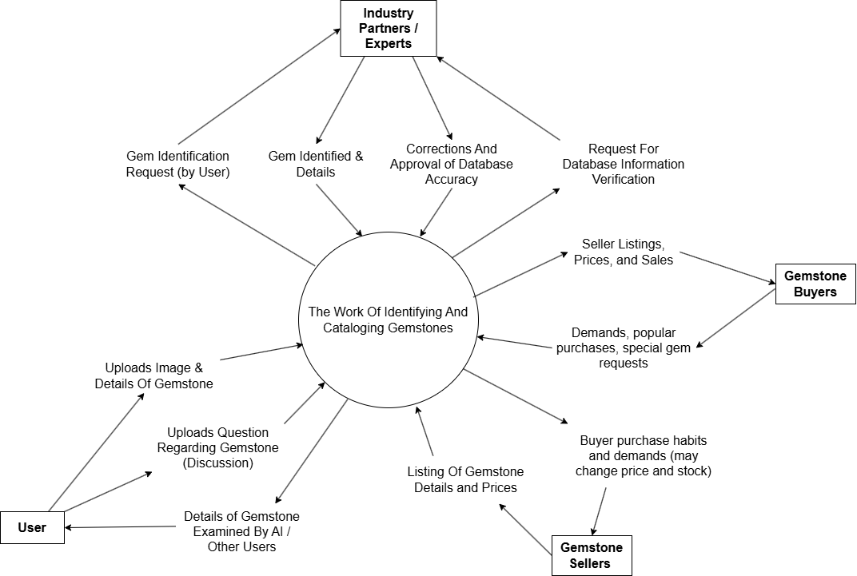
Figure 1 - Work Context Diagram
Visualization of the kinds of interactions Project Amethyst facilitates between the different types of users.
The official services used at each component are left to be determined. However, the system must be able to support the following:
- Users - Upload gemstone images and details, request identification, participate in forums, browse listings, and initiate purchases/sales.
- Industry Partners / Experts - Provide data, credentials, and professional feedback to improve catalogue accuracy and brand reliability.
- Gemstone Sellers - List gemstones for sale, provide pricing and product details, and fulfill orders placed through the marketplace.
- Gemstone Buyers - Browse available listings, submit purchase requests, and influence pricing trends through demand and buying behavior.
- Payment Services - Handle secure transaction processing and payment confirmation for marketplace purchases.
- Cloud Infrastructure / AI Services - Perform gemstone image analysis, store catalogue data, manage user accounts, and support real-time system operations.
The center of the diagram represents the core work of identifying, cataloging, valuing, and exchanging gemstones. External things interact with this center by submitting info, receiving results, and contributing to marketplace activity and catalogue refinement.
3c Work Partitioning
Event Name | Input & Output | Summary
User Requests Gem Identification by AI | Images & Details of Gem (in)  Details of Probable Gemstone with confidence >= 80% (out)  Directions to make a Request For Identification to experts or public in failure (out) | The user submits details and images for AI processing, and AI returns either general information of its identified gem (if confidence is over 80%) or directions to make a post to the discussions or experts for identification.
User Requests Gem Identification by Community and/or Experts | Images & Details of Gem (in)  Feedback and responses from users and experts (out) | The user makes a post in Discussions with the tag “Needs ID” which will be exposed to other users and experts who may be able to help with identification.
Gemstone Buyer makes a purchase | Items purchased and payment (in)  Delivery details, shipping number, courier service, etc from seller (out) | The buyer makes a purchase from a seller on Marketplace and receives order details such as estimated arrival date, shipping number, etc.
Industry Expert/Professional or User makes a correction to the Catalogue details | Change to be made and evidence of mistake (in)  Corrections made during maintenance to server by IT (out) | If an Industry Professional or User points out and submits a request of correction to the Catalogue with evidence of mistake, it is reviewed among other experts before being carried out during server maintenance
Table 1 - Work Partitioning List
3d Competing Products
Kassoy Gemstone Testing Tools
Kassoy provides manual gemstone testing lab tools such as refractometers and polariscopes used by professionals. While these tools offer good accurate results, they require scientist knowledge and physical equipment that you have to buy, making them impractical for casual users and hobbyists.
Wikipedia and GIA Gem Encyclopedia
Wikipedia and the GIA Gem Encyclopedia provide general information about gemstones. However, users must already know what gemstone they have, and these platforms do not offer image-based id, valuation, or marketplace features.
Amazon and eBay
Amazon and eBay allow users to buy and sell gemstones online, but they do not provide authentication, identification, or educational support. Listings rely completely on seller descriptions, which can be inconsistent or inaccurate.
Reddit (r/Gemstones)
r/Gemstones offers a community space for discussing and identifying gemstones. While helpful, responses vary in accuracy and there is no structured verification or integration with valuation or sales.
Project Amethyst will combine all these tools into one intuitive application for beginners, sellers and industry professionals. It would also be more reliable as information and processes can be more easily regulated by the programmers and partnered industry companies for correctness and accuracy. Users will not have to download and learn to use multiple applications as they would have to now.
- Scope of the Product

Amethyst serves as a mobile application that identifies, categorizes, and estimates the market value price of various different gemstones. Along with user inputs such as weight and size, Amethyst utilizes advanced AI software that integrates multiple gemstone inspection techniques and tools such as color analysis, refractive index measurement (refractometer), spectral absorption analysis for chemical composition (spectrometer), and quality assessment for any impurities to create a complete and comprehensive profile of the gemstone along with an accurate value estimate. Included in the stone’s profile would be its type, quality, cut, any information about the location in which the stone was formed, information about exactly how the stone was formed, if the stone was lab grown or not, and any causes for the stone’s color (trace elements inside the stone).

Amethyst also aims to foster a vibrant and collaborative community of gemologists and collectors through shared knowledge and marketplace interaction. Amethyst’s marketplace will connect users from around the world and allow them to purchase and sell gemstones. Amethyst’s discussion forum will allow users to ask questions, share gemstone discoveries, seek expert advice, and discuss identification results generated by the AI tool.

4a Scenario Diagram(s)
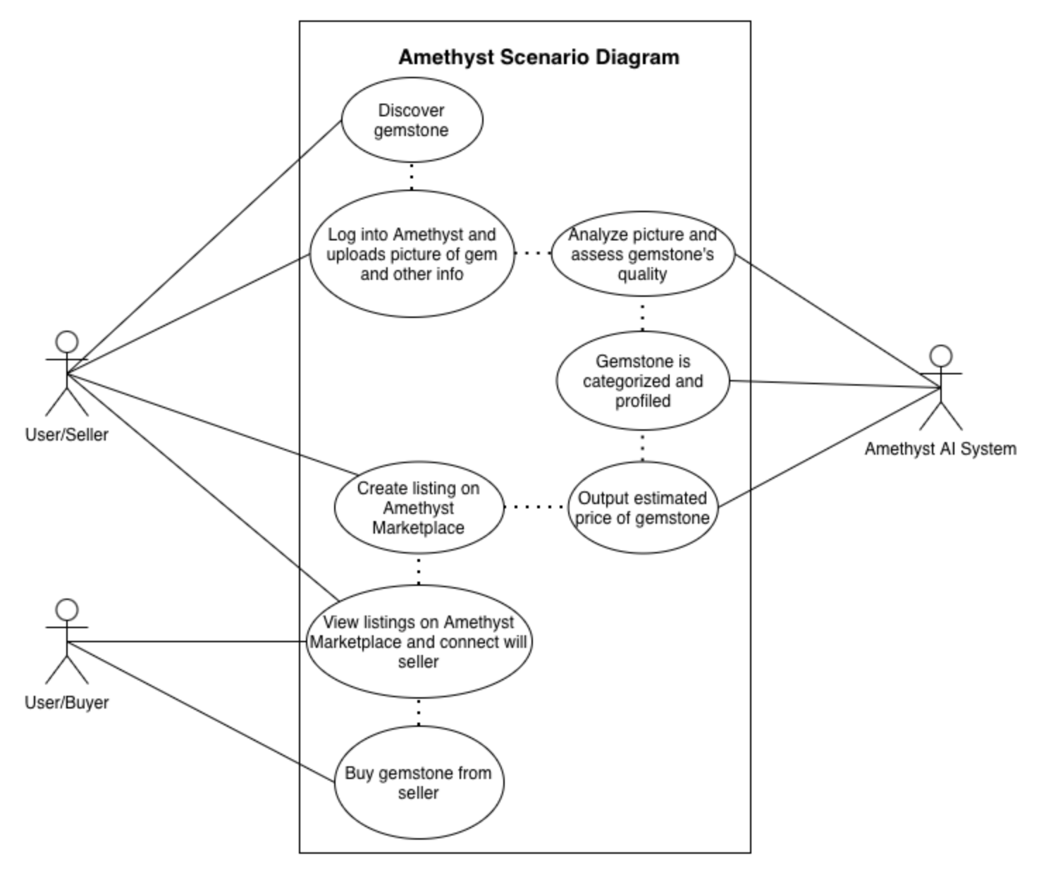
Figure 2 - Scenario Diagram
A seller uploads a gemstone to Amethyst where it analyzes and estimates its value for marketplace listing and a buyer then views and purchases the gem through the app.

4b Product Scenario List

Name | External Actors | Relevant Information
S1. Gemstone Identification | User, Amethyst | Users use Amethyst’s AI gem identification software to identify various gemstones.
- S1.1. Account Login | User, Amethyst | Users must log in to their Amethyst accounts to use the app’s gem identification tool.
- S1.2. Gem Picture Upload | User, Amethyst | After logging in to Amethyst, users can upload pictures of their gems where it analyzes it to determine the gemstone’s type and verify its authenticity.
S2. Marketplace | User, Amethyst | Users can utilize Amethyst’s built in marketplace to sell or buy gemstones.
- S2.1. Gem Profile and Value Estimation | Amethyst | Amethyst compiles a comprehensive profile of the user’s gemstone which includes the gemstone’s type, quality, and estimated value
- S2.2. Product Listing / Selling Gemstone | User, Amethyst | After a complete profile has been generated by Amethyst, users can list their gemstone on Amethyst’s marketplace for sale for a fixed price or for bidding.
- S2.3. Buying Gemstone | Users (2), Amethyst | Users can buy or bid on any gems that are listed in the marketplace.
- S3. Discussions | Users | Users can make posts on Amethyst’s discussion forum to discuss anything pertaining to gemstones or gemology in general.
- S3.1. Discussion Forum | Users | Users can make comments under a post and join in on a discussion.
Table 2 - Product Scenario List

4c Individual Product Scenarios

S1. Gemstone Identification

S1.1 Account Login: Sarah launches the Amethyst app and logs in using their account credentials, after which the system verifies the information, authenticates the user, and redirects her to the main application interface.

S1.2 Gem Picture Upload: After digging for hours, Mark, an avid miner, discovers what appears to be a gemstone. It is blue and greenish in color. He wants to identify the stone and verify that it is real. Mark snaps a picture of the stone, logs in to the Amethyst app, uploads the picture, and uses its gem identification tool to determine the gem’s type. He is thrilled to find that he has discovered a rare type of sapphire!

S2. Marketplace

S2.1 Gem Value Estimation: Lisa and her team consisting of 6 members are required to find over $500 worth of rubies on their expedition in a cave in Myanmar. They have discovered over 8 rubies in total over the course of their time in the cave. Instead of guessing the value, they upload pictures of each stone and upload it to the Amethyst app. The app returns an accurate value estimation of over $780 for all 8 rubies.

S2.2 Product Listing/Selling Gemstone: 5 years after finding a perfect Opal on his most recent expedition in a Montana cave system, Alan decides he wants to finally sell the gemstone to an enthusiastic buyer. He uses Amethyst to provide a market value estimation and generate a profile of the gemstone. Due to the gemstone’s high quality and size, Amethyst estimates the stone is worth $1,525. He lists the stone on Amethyst’s marketplace for $1,800 and awaits a potential buyer.

S2.3 Buying Gemstone: Amber wishes to purchase a high quality gemstone as a birthday gift for her best friend. She browses the marketplace, reviews gemstone details and Amethyst’s value estimates. She finally finds a gemstone in excellent condition. She’s able to view the stone’s profile that was compiled from Amethyst and discovers a great deal of information about the stone such as cut, type, clarity, and where the stone was formed. She contacts the seller and completes the purchase through the app. She is excited to give the gemstone to her best friend during her birthday party.

S3. Discussions

S3.1 Discussion Forum: Over the years, Jessica has become more and more intrigued with Gemology. She started her collection a few months ago and has a substantial amount of gemstones already. She wants to share her collection with like minded gem hobbyists and gemologists. She makes a post on Amethyst’s discussion forum showcasing all of her amazing gems. Others join the conversation by making comments under her post and discussing which of her gems are their favorite.

- Stakeholders

5a The Client

The primary client of the Amethyst application is our development team, which is responsible for commissioning, designing, and maintaining the platform. As the client, we define system requirements, oversee implementation, and ensure the application meets its intended goals for functionality, performance, and long-term sustainability. Additionally, investors function as financial clients by funding development and expecting long term returns. Together, these client groups contribute to the economic viability and strategic direction of the Amethyst app.

5b The Customer

The primary consumers for Amethyst will be gemstone hobbyists and collectors. Amethyst offers these users easy, fast, and accurate gemstone analysis thus allowing users to completely streamline traditionally complex gemological techniques. Instead of spending substantial amounts of time and money getting their gems appraised, the app removes those barriers by delivering instant identification and valuation to the user. Also, buying stones from Amethyst’s marketplace gives them the ability to effortlessly expand their gemstone collection.

5c Hands-on Users of the Product

User name / category: Gemstone enthusiasts

User role: These are individual collectors and hobbyists that will use the app to identify, catalog, and possibly trade gemstones.

Gemological experience: [Journeyman] They understand the fundamental properties of various different gemstones such as cut, clarity, hardness, etc. but they lack any formal gemological training or laboratory experience.

Technological experience: [Varied] Technological familiarity within this group will range from basic to intermediate. Many users will be comfortable using smartphones, social media platforms, and online marketplaces, allowing them to easily navigate Amethyst’s interface, upload gemstone images, and participate in forum discussions. However, some users may require brief guidance when interacting with more advanced features such as AI-generated reports.

Other: While these users possess no formal gemological training, they are driven by curiosity, passion, and personal interest in gemstones. Many of the users here will be motivated by collection building, personal enjoyment, or potential resale opportunities. They will also contribute greatly to Amethyst’s discussion forum by posing questions, seeking advice, and sharing discoveries.

User name / category: Professional gemologists

User role: Certified experts and trained professionals in the field of gemology who may use Amethyst as a supplemental identification, valuation, and marketplace tool.

Gemological experience: [Master] Since they are more experienced in the field of Gemology, they have excellent knowledge in how to identify different types of gemstones, their chemical composition, the formation process, and where they were most likely formed.

Technological experience: [Varied] Amethyst may provide a steeper learning curve for younger gemologists whereas older generations may have a more shallow learning curve. Younger and more digitally engaged professionals may adapt quickly to Amethyst’s AI gem identification tool and Amethyst’s UI while senior professionals may require a short adjustment period moving from more traditional gem analyzation tools and techniques to a more advanced digital platform.

Other: The users here will be able to contribute to discussions on Amethyst's discussion forum. Their knowledge of gemstones is essential in providing high quality conversations that keep users engaged with the platform. Their expertise allows them to provide authoritative insights within the discussion forum, validate AI generated reports, and elevate the overall standard of discourse. Generally, they will have a higher education than most other users.

User name / category: Casual buyers / shoppers

User role: The average person only interested in purchasing gems as gifts or for personal jewelry.

Gemological experience: [Novice] They have very limited to absolutely no knowledge in Gemology as a whole. They are able to differentiate between gemstones due to external factors like color, but they are generally unaware of any moderate to advanced gemological concepts.

Technological experience: [Journeyman] These users are comfortable with everyday technology such as mobile apps and online shopping platforms. They can upload images, browse listings, and interact within forums, but may require clear instructions for more advanced features.

Other: Educational content, clear explanations of gemstone qualities, and transparent marketplace reviews are especially important to this group. While the users here may not actively participate in detailed gemological discussions, they may browse the forum to read recommendations or seek reassurance before completing a purchase.

5d Maintenance Users and Service Technicians

Software Engineers / Developers
The developer’s main purpose is to maintain, update, and improve Amethyst’s backend systems, frontend systems, and AI models. They are responsible for maintaining server reliability, improving marketplace functionality, addressing any performance issues, and fixing any bugs.

Database Engineers / Administrators
Their main role is managing gemstone records, transaction histories, and marketplace listings. Their responsibilities include ensuring data integrity, monitoring backup and recovery systems, secure sensitive transaction data from users, and optimizing and maintaining database performance.

5e Other Stakeholders

Jeweler Retailers and Suppliers

Stakeholder: Independent jewelry store owner

Knowledge needed: Typically this stakeholder would need to know industry standard gemstone pricing and authentication as well as gemstone market demand trends.

Degree of Involvement:[Moderate to High] Retailers may provide feedback on things like marketplace features, valuation accuracy, and sourcing functionality.

Degree of Influence:[High] Their participation impacts marketplace credibility, transaction volume, and pricing standards.

Conflict Resolution: If conflicts arise between retailers and individual sellers, Amethyst will rely on AI valuation methodology, seller rating systems, and clear marketplace policies to ensure fair resolution. Dispute resolution mechanisms and third-party certification references will be used when necessary.

Gem Certification Organizations

Stakeholder: Gem Certification Organization Representative

Knowledge needed: This stakeholder needs to be aware of industry standard gemstone grading as well as knowledge of gem certification documentation.

Degree of Involvement:[Moderate] They may serve as reference authorities to ensure AI-generated reports align with professional standards.

Degree of Influence:[High] Certification organizations significantly affect Amethyst’s credibility and legal positioning.

Conflict Resolution: If AI identification conflicts with certified laboratory reports, certified documentation will take precedence. Amethyst will clearly state that AI generated results are estimates and not official certifications, reducing legal and professional conflict.

5f User Participation

Gem Enthusiast/Hobbyist: These users, as the primary users of Amethyst, are expected to play a significant role during the development process. Their participation is essential in providing usability feedback on the mobile interface, offering input on the marketplace browsing experience, clarifying requirements for AI generated gemstone reports, and helping prioritize features related to gemstone cataloging tools. The knowledge they contribute includes user experience expectations, concerns regarding the marketplace, and the need for accessible educational content. Without sufficient involvement from this group, there is a significant risk that the application may become overly complex or fail to meet user expectations. It is estimated that this group will use the app around 3-5 hours per week.

Professional Gemologist: Professional Gemologists are expected to contribute primarily to the validation and refinement of Amethyst’s AI identification and valuation systems. Their involvement includes reviewing and validating the gemstone identification logic, ensuring the accuracy of terminology used in AI generated reports, providing input on valuation standards, and contributing to the structure and credibility guidelines of the discussion forum. The knowledge they provide encompasses industry standards, certification practices, identification best practices, and professional expectations within the field of gemology. Their involvement is essential in maintaining professional credibility for the platform. It is estimated that this group will utilize this app a minimum of 2-3 hours per month.

Casual Shoppers: Casual Buyers and Shoppers are expected to contribute primarily to the refinement of the marketplace experience. Their participation will focus on providing feedback regarding marketplace trust indicators, the clarity of gemstone descriptions, the ease and efficiency of the purchasing flow, and overall pricing transparency. The knowledge they provide includes insight into consumer purchasing behavior, expectations surrounding simplicity and trust, and navigation clarity within the application. It is estimated that this group will utilize this app for a minimum of 1-2 hours per month.

5g Priorities Assigned to Users

Key Users: Gem Enthusiasts/Hobbyists
Gemstone enthusiasts would be considered Amethyst’s key users because they represent the primary customer base of Amethyst. They will drive marketplace activity, engage heavily with the AI gem identification tool, and contribute significantly to the app’s discussion forum which will keep users engaged with the app.

Secondary Users: Professional Gemologists
Professional gemologists would be considered Amethyst’s secondary users because they would not be the primary revenue drivers. While they will contribute to the platform’s credibility and discussion quality, they will more than likely not represent a large portion of the users that will purchase gemstones from the marketplace or use the AI gem identification tool.

- Mandated Constraints

6a Solution Constraints

Description: The product shall be developed as a mobile application for iOS and Android operating systems.

Rationale: The primary users rely on smartphones to photograph gemstones, browse the marketplace, and participate in the discussion forum. A desktop only solution would not meet accessibility and usability expectations.

Fit Criterion: The product shall be installable and fully functional on the two most recent major versions of both iOS and Android operating systems.

Description: The product shall use a cloud infrastructure for AI processing, data storage, and marketplace transactions.

Rationale: AI gemstone identification and valuation require scalable processing power and centralized data management. A local only solution would not support real time model updates or global marketplace activity.

Fit Criterion: All gemstone identification processing and user data storage shall be handled through secure cloud-hosted servers with uptime of at least 99%.

Description: The product shall comply with applicable data privacy regulations for user data storage and transactions.

Rationale: The platform handles personal information and financial data, requiring legal compliance to operate internationally.

Fit Criterion: The system shall implement encrypted data storage and secure authentication protocols consistent with recognized data protection standards.

Description: The product shall have a PCI DSS (Payment Card Industry Data Security Standard) compliant payment processing system.

Rationale: Amethyst includes a global marketplace involving financial transactions, which requires secure and legally compliant payment handling.

Fit Criterion: All marketplace transactions shall be processed using encrypted payment gateways that meet PCI DSS compliance standards.

6b Implementation Environment of the Current System
The Amethyst application will operate within a modern mobile and cloud based technological environment. The product will be designed as a mobile application installed on user smartphones and tablets running iOS versions 17 and beyond and Android 14 (Upside Down Cake) and beyond. These devices provide the primary hardware environment, including camera systems for gemstone image capture, touch interfaces, and wireless connectivity for communication with backend services. The application will interact with a cloud infrastructure that will be responsible for AI gemstone identification processing, data storage, marketplace transaction management, and discussion forum content management. The backend system will operate on secure cloud servers capable of handling scalable computational workloads required for image recognition and valuation modeling.
Amethyst will integrate with third party systems, including secure payment gateways for marketplace transactions, email and push notification services for communication, and authentication services for account management. Communication between mobile devices and backend servers will occur over encrypted internet connections using standard HTTPS protocols.
6c Partner or Collaborative Applications
The Amethyst application must integrate with several external partner applications and services in order to function effectively within its operational environment. While these systems are not part of the product itself, they are essential for enabling marketplace transactions, user authentication, communication services, and cloud infrastructure support. For example, utilizing third party payment processing systems such as Shopify and or PayPal will be paramount for handling financial transactions within the marketplace. Amethyst must securely transmit transaction data to the payment processor and receive confirmation of completed payments and collaborating with either of those parties will give it the ability to do so.
Amethyst will also integrate with cloud hosting platforms such as Amazon Web Services or Google Cloud Platform. These services provide server infrastructure, data storage, and computational resources necessary for AI gemstone identification and marketplace functionality. The application must interface with these cloud systems through secure API endpoints.
Additionally, user authentication services may be supported through external providers such as Google or Apple Sign In. These partner applications enable secure account creation and login processes.
6d Off-the-shelf Software

The Amethyst application shall be developed using a mandated technology stack consisting of a backend Web API built with the .NET Framework in C#, which will handle business logic, AI integration endpoints, marketplace processing, and user account management. The frontend website shall be implemented using JavaScript or TypeScript along with HTML and CSS to ensure modern browser compatibility and responsive design. The mobile application shall be developed using Kotlin for Android and Swift for iOS. All gemstone catalogue data, user accounts, marketplace listings, and transaction records shall be stored and managed using Microsoft SQL Server, with database administration conducted through SQL Server Management Studio. These technologies are non-negotiable and define the technical boundaries within which the final product must be implemented.

6e Anticipated Workplace Environment

The Amethyst application will primarily function as a mobile application intended for use in a variety of real world environments, including outdoor gemstone hunting locations, trade shows, retail stores, offices, and private homes. Because users may operate the mobile application while standing, traveling, or working in nontraditional settings, the interface must be optimized for handheld use, touch navigation, and quick interactions. In office environments, particularly within the gem industry or among professional sellers, the web based version of the application will be used in quieter and more controlled settings, where users may expect detailed analytics and extended browsing sessions. The system requires a stable internet connection because gemstone data, marketplace listings, and discussion forum content are stored on remote servers rather than locally on the device. Features such as gemstone identification, marketplace browsing, and forum participation depend on real time server communication. Mobile devices must have access to camera and photo gallery functionality to allow users to upload gemstone images for AI analysis. The design must also account for possible backend service interruptions such as server maintenance or connectivity loss by providing appropriate user notifications and graceful error handling. The platform must also accommodate a mix of novice hobbyists and professional gemologists, requiring clear explanations for beginners while maintaining credibility and professional tone for experts.

6f Schedule Constraints
The initial release of Amethyst is not currently dependent on existing industry contracts or operational deadlines. However, timely release is important to establish early market presence and competitive advantage in the AI driven gemstone marketplace space. Delays may reduce first mover advantage and slow user adoption.
If future agreements are established with gem mining companies or jewelry retailers, additional integration requirements and fixed delivery deadlines may be introduced. Internal milestones require completion of backend development before mobile integration testing and beta testing prior to marketplace launch. Failure to meet these milestones may delay product release and revenue generation.
6g Budget Constraints

The development of Amethyst is constrained by available financial and resource limitations. Major cost factors include cloud server infrastructure for database storage and backend services, development and testing labor for the mobile application and web platform, marketing efforts targeting the gemstone community and industry, potential custom integrations requested by mining corporations or business partners, and gem identification AI model improvements and upgrades. Taking all of this into consideration, the initial budget will be around $300,000 USD.

- Naming Conventions and Definitions

7a Definitions of Key Terms

Terms | Meaning/Referencing
Gemstone Industry | The corporations and laboratories that mine, process, research and/or sell gemstones.
Industry Experts/Professionals | The people in the field of gemology with qualifications that are trusted by the wider scientific community and industry.
Gemstone | A mineral or petrified material that when cut and polished can be used in jewelry.
Discussion Forum | A sector of the app where users can communicate and interact with one another as a community.
Valuation Estimate | An AI generated approximation of a gemstone’s market value.
Gemstone Identification | The process of determining the type and classification of a gemstone based on its physical and optical properties.
Gem Profile | A digital report generated by the system containing gemstone type, properties, estimated value, and confidence score. The word “report” is commonly interchanged with the word “profile” but they both refer to the same entity.
Marketplace | A sector of Amethyst where users can purchase or sell gemstones.
Catalogue | UI of the Amethyst database that the gem identification AI refers to to display information about the user's stones.

7b UML and Other Notation Used in This Document

This report follows the UML 2.0 standard as described by Martin Fowler in UML Distilled. Unified Modeling Language is used throughout this document to represent data relationships, use cases, and component interactions in a standardized and widely recognized format. Any deviations from standard UML conventions are explicitly stated within the relevant sections.

7c Data Dictionary for Any Included Models

Gemstone Profile:

Field Type Description
gemID | int | Primary key
gem_Type | string | Sapphire, ruby, etc.
color | string | Standard color scale
cut | string | Excellent, good, fair, etc.
clarity | string | Gemstone grade (EL, IF, VVS1, etc.)
valuation_Estimate | float | AI generated value estimate of stone
carat | float | Weight of stone.  Range: > 0
location | string | Geographic origin of stone
chem_Composition | string | Mineral formula of stone
value_Info | string | Other descriptive info about stone

User:

Field Type Description
user_ID | int | Primary key
Username | string | Account name
email_Address | string | Valid email format
password | string | Password for account
gem_Profiles | List<> | User owned gemstones
transaction_History | List<> | purchase/sale records

Discussion Forum:

Field Type Description
post_ID | int | Primary key
user_ID | int | ID of user that made original post
title | string | Title of post
content | string | Post text
upvotes | int | Likes on comment
downvotes | int | Dislikes on comment
comments | List<> | Comments under post
timestamp | DateTime | Date the post was created

Marketplace Listing:

Field Type Description
listing_ID | int | Primary key
seller_ID | int | Primary key
gem_ID | int | Primary key
listing_Status | string | Active, sold, etc.
price | float | Cost of gemstone in listing
gem_Image | string | Image of gemstone for sale
date_Posted | DateTime | Date listing was created

- Relevant Facts and Assumptions
8a Facts
- Gemstone identification based on images is inherently probabilistic, as many gemstones share similar visual characteristics.
- Accurate gemstone valuation depends on multiple external factors including clarity, cut, size, origin, treatments, and current market demand.
- Users will submit gemstone photos taken in uncontrolled environments with varying lighting and camera quality.
- Online gemstone marketplaces currently lack built-in authentication and rely heavily on user-provided information.
- Marketplace transactions require secure payment processing and data protection mechanisms.

8b Assumptions
- We assume users will access Amethyst primarily through smartphones with functioning cameras and internet.
- We assume users will upload reasonably clear images and provide basic gemstone details such as size or weight when available.
- We assume users will comply with marketplace policies and applicable trading regulations.
- We assume core development technologies (JavaScript/TypeScript, Kotlin, Swift, SQL, and backend frameworks) will remain supported and viable throughout the project lifecycle.
- We assume the catalogue will require continuous updates and validation by professionals and community feedback.

II Requirements
- Product Use Cases
9a Use Case Diagrams
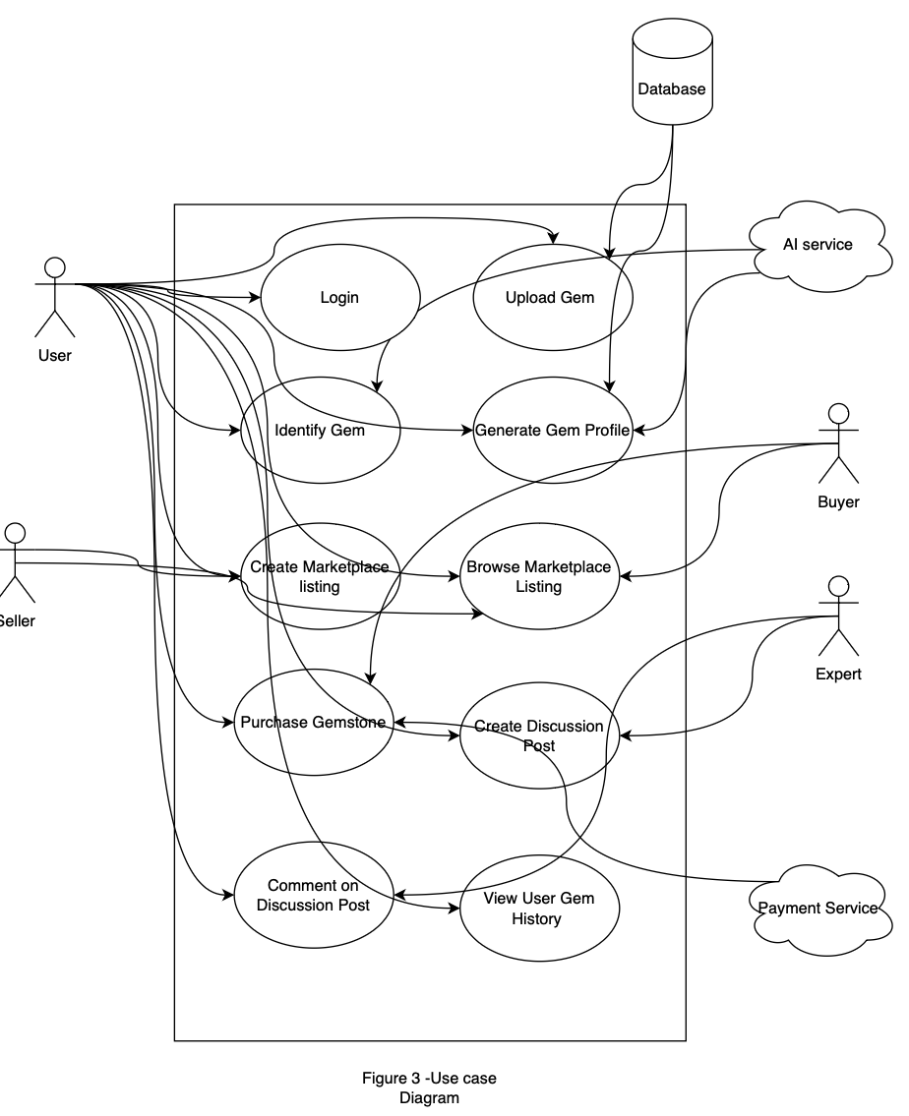
Figure 3 - Use Case Diagram

9b Product Use Case List

Gem Identification | Marketplace | Discussion Forums
Gem Upload | Create Marketplace Listing | Create Discussion Post
Identify Gem | Browse Marketplace | Comment on Discussion Post
Generate Gem Profile | Purchase Gemstone | Delete Discussion Post
View Gem History | Reaching out to Seller | Report Discussion Post
Browse through Historic Gemstone Profiles | Report misleading listing
Table 3 - Product Use Case List

9c Individual Product Use Cases
Use case ID: UC-01 Name: Uploading Gem
pre-conditions: User is logged in and has access to the gemstone
post-conditions: A gemstone image and it’s details are stored for analysis
Initiated by: User
Triggering Event: user chooses to submit gemstone for identification
Additional Actors: N/A
Sequence of Events:
- User opens the gemstone identification page.
- System displays image upload fields.
- User uploads one or more gemstone pictures.
- User enters gemstone details such as weight, size etc.
- System validates the uploaded files and entered data
- System saves the submission for identification.
Alternatives: User uploads only one image instead of multiple images
User leaves optional detail blank.

Exceptions: Uploaded image format is unsupported.
Required description is missing and the system rejects the submission.

Use case ID: UC-02 Name: AI Gemstone Identification
pre-conditions: Valid gemstone image and details already submitted post-conditions: System returns a gemstone type and confidence score, or directs the user to expert help.
Initiated by: User
Triggering Event: User requests analysis of the submitted gem
Additional Actors: AI / Cloud service
Sequence of Events:
- IUser submits the gemstone identification request.
- System sends the gemstone image and details to the AI analysis service.
- AI service analyzes the gemstone submission.
- AI service returns a probable gemstone type and confidence score.
- System displays the identification result to the user.
- If confidence is sufficient, the system proceeds toward gem profile generation.
- If confidence is low, the system recommends that the user create a discussion post or seek expert help.
Alternatives: User accepts the AI result and continues to the gem profile.

Exceptions: AI service fails to return a result.
Network or cloud service interruption fails analysis.

Use case ID: UC-03 Name: Generate Gem Profile and Value Estimate
pre-conditions: The gemstone has been successfully analyzed by the AI. post-conditions: A gem profile is created and saved to the user’s account.
Initiated by: System
Triggering Event: AI ID completed successfully
Additional Actors: AI / Cloud service
Sequence of Events:
- System gets the gemstone identification result.
- System creates gemstone attributes such as type, quality, confidence score, and estimated value.
- System creates a gem profile.
- System saves the profile to the user’s account.
- System displays the complete gem profile to the user.
Alternatives: User views the profile only.
User continues from the profile to create a marketplace listing.

Exceptions: The value estimate cannot be made.
Profile data is incomplete

Use case ID: UC-04 Name: Create Marketplace Listing
Pre-conditions: User has a generated gem profile.
Post-conditions: A gemstone listing is published to marketplace.
Initiated by: User
Triggering Event: User chooses to sell a gemstone
Additional Actors: N/A
Sequence of Events:
- User opens a gem profile
- System displays an option to create a marketplace listing.
- User selects the listing option.
- System prompts the user to choose a sale format and enter listing info.
- User selects fixed price or bidding and confirms.
- System creates and publishes the marketplace listing.
- System displays the new listing in the marketplace.
Alternatives: User saves the listing as draft and publishes later.
User edits pricing before final submission.

Exceptions: Required listing fields are missing.
System fails to publish the listing.

Use case ID: UC-05 Name: Browse and View Marketplace
Pre-conditions: User is logged in
Post-conditions: User views one or more gemstone listings and their details.
Initiated by: User
Triggering Event: User opens the marketplace.
Additional Actors: N/A
Sequence of Events:
- User navigates to the marketplace.
- System displays available gemstone listings
- User browses listings or searches for a specific one.
- System updates the displayed results.
- User selects a listing.
- System displays the full listing details, including gemstone profile, seller information, and pricing.
Alternatives: User filters by gemstone type, price, or other characteristics.
User views multiple listings before choosing one.

Exceptions: No listings match the user’s search.
Marketplace data cannot be loaded.
No one posted on Marketplace.

Use case ID: UC-06 Name: Purchase Gemstone
Pre-conditions: User has selected an active listing they wants to buy
Post-conditions: Purchase is completed and transaction details are stored.
Initiated by: User
Triggering Event: User chooses to buy a gemstone from the marketplace.
Additional Actors: Payment Service, Seller
Sequence of Events:
- User selects a gemstone listing in the marketplace.
- System displays gem info and purchase option
- User enters or confirms purchase details.
- System sends payment information to the payment service.
- Payment service confirms or rejects the transaction.
- If approved, system records the transaction
- System displays confirmation details to the buyer.
Alternatives: User cancels purchase
User returns to browsing without buying.

Exceptions: Payment is rejected.
The listing is no longer available at checkout.

Use case ID: UC-07 Name: Create Discussion Post
Pre-conditions: User is logged in and discussion forums are available
Post-conditions: A new discussion post is published to the forum.
Initiated by: User
Triggering Event: User chooses to create a forum post.
Additional Actors: Expert / Community User
Sequence of Events:
- User navigates to the discussion forum.
- System displays the option to create a new post.
- User enters a title, content, and optional tag
- User submits the post.
- System stores the post and associates it with the user
- System displays the post in the discussion forum feed.
Alternatives: User creates a general discussion post instead of an identification request
User adds a tag to post

Exceptions: User posts content that is empty or invalid
System fails to save the post
User post/comments content that is not allowed/inappropriate

Use case ID: UC-08 Name: Commenting on Discussion Post
Pre-conditions: A discussion post already exists
Post-conditions: User comment is added to the post
Initiated by: User
Triggering Event: User chooses to reply to a discussion post
Additional Actors: Expert / Community User
Sequence of Events:
- User opens a discussion post.
- System displays the existing comments and post
- User enters a comment and submits the comment.
- System stores the comment and links it to the selected post.
- System displays the comment in either chronological order or popular order
Alternatives: User edits comment
User reads comments without adding one

Exceptions: Comment fails to post
Comment is empty/invalid

Use case ID: UC-09 Name: View User Gem History
Pre-conditions: User is logged in and has previous activity saved in the system
Post-conditions: User views saved gemstones
Initiated by: User
Triggering Event: User opens account history
Additional Actors: N/A
Sequence of Events:
- User goes to gemstone history page
- System displays the history section
- User selects past record such as a gem profile or listing
- System gets that data
- System displays the saved data
Alternatives: User filters history by type

Exceptions: No history exists for user
System fails to retrieve data

- Functional Requirements
#F-01: Account Login
Description: The system allows users to log in to their Amethyst account using a valid account before accessing core application features such as gemstone identification, marketplace activity, and discussion participation. If invalid credentials are entered, the system shall deny access and display an error message.
Rationale: Users must be authenticated so their gemstone reports, listings, purchases, and forum activity can be tied to the correct account securely.
Fit Criterion: In testing, a user with valid credentials is redirected to the main application interface, while a user with invalid credentials remains on the login screen and receives an appropriate error message.
Acceptance Tests: F-01, F-02

#F-02: Upload Gem Image and Details
Description: The system allows a user to upload one or more gemstone images and enter additional gemstone details such as weight, size, and discovery information. The system shall accept only supported image formats and required metadata fields.
Rationale: The gemstone identification process depends on both image input and user-provided details in order to produce meaningful results.
Fit Criterion: In testing, the system successfully stores a valid image submission with the required gemstone details and rejects incomplete or unsupported submissions with a clear message.
Acceptance Tests: F-03, F-04

#F-03: AI Gemstone Identification
Description: The system shall analyze an uploaded gemstone image and associated details using AI to identify the probable gemstone type and return a confidence score. If the confidence score is too low, the system shall direct the user to request help from the discussion forum or experts.
Rationale: The main value of Amethyst is giving users a fast and accessible way to identify gemstones without relying only on outside research or expensive professional testing.
Fit Criterion: In testing, the system returns a gemstone type and confidence score for valid submissions, and low-confidence cases display an alternate recommendation to seek community or expert input.
Acceptance Tests: F-05, F-06

#F-04: Generate Gem Profile and Estimate Value
Description: After a gemstone has been analyzed, the system shall generate a gem profile containing characteristics such as gemstone type, quality, estimated value range, and discovery-related information when available. This profile shall be viewable by the user and reusable for later marketplace actions.
Rationale: Users need more than just a gemstone name; they also need a structured profile and estimated value to support learning, collecting, or selling decisions.
Fit Criterion: In testing, a successfully analyzed gemstone produces a profile page containing the required fields, including gemstone type and value estimate.
Acceptance Tests: F-07, F-08

#F-05: Marketplace
Description: The system shall allow a user to create a marketplace listing for a gemstone after a gem profile has been generated. The user shall be able to select a sale format such as fixed price or bidding and provide listing details before publishing.
Rationale: A major goal of Amethyst is to let users move directly from identification and valuation into selling gemstones in the same platform.
Fit Criterion: In testing, a user can publish a listing tied to an existing gem profile, and the listing appears in the marketplace with the selected sale format and pricing information.
Acceptance Tests: F-09, F-10

#F-06: Browse and View Marketplace Listings
Description: The system shall allow users to browse gemstone listings in the marketplace and view detailed information about each listed gemstone, including its profile, pricing, seller information, and estimated value. The system shall support filtering or searching listings by relevant gemstone characteristics.
Rationale: Buyers need enough information to compare listings and make informed purchasing decisions inside the application.
Fit Criterion: In testing, users can open the marketplace, view multiple gemstone listings, apply at least one search or filter option, and access the full details of a selected listing.
Acceptance Tests: F-06

#F-07: Purchase Gemstone
Description: The system shall allow a buyer to initiate and complete a gemstone purchase through the marketplace. After payment is confirmed, the system shall record the transaction and display order-related details to the buyer.
Rationale: The marketplace is only useful if buyers can complete transactions and receive confirmation that the purchase was successful.
Fit Criterion: In testing, a buyer can complete checkout for an available gemstone listing, and the system records the purchase and displays confirmation details.
Acceptance Tests: F-07

#F-08: Create Discussion Posts
Description: The system shall allow users to create discussion forum posts related to gemstones, including posts requesting identification help or sharing discoveries. Each post shall be visible to other users in the discussion forum after submission.
Rationale: The discussion forum supports community knowledge-sharing and gives users another path when AI results are uncertain or when they want to engage with other enthusiasts.
Fit Criterion: In testing, a logged-in user can submit a discussion post and the post becomes visible in the forum feed with the correct title, content, and tag if applicable.
Acceptance Tests: F-08

#F-09: Comment on Discussion Posts
Description: The system shall allow users to comment on existing discussion forum posts and view comments made by others. Comments shall be attached to the correct post and displayed in chronological order.
Rationale: The community aspect of Amethyst depends on users being able to respond to one another, provide advice, and discuss gemstones collaboratively.
Fit Criterion: In testing, a user can submit a comment under a post, and the comment appears under the correct discussion entry in the proper sequence.
Acceptance Tests: F-09

#F-10: Save User Gem History
Description: The system shall store a user’s past gemstone analyzes, generated gem profiles, marketplace listings, and purchases within their account history. Users shall be able to revisit previously saved gemstone records.
Rationale: Users may want to return to old gemstone reports for learning, resale, tracking collections, or reviewing prior marketplace activity.
Fit Criterion: In testing, previously analyzed or listed gemstones remain accessible in the user’s account after logout and login, and each saved record opens correctly.
Acceptance Tests: F-10

- Data Requirements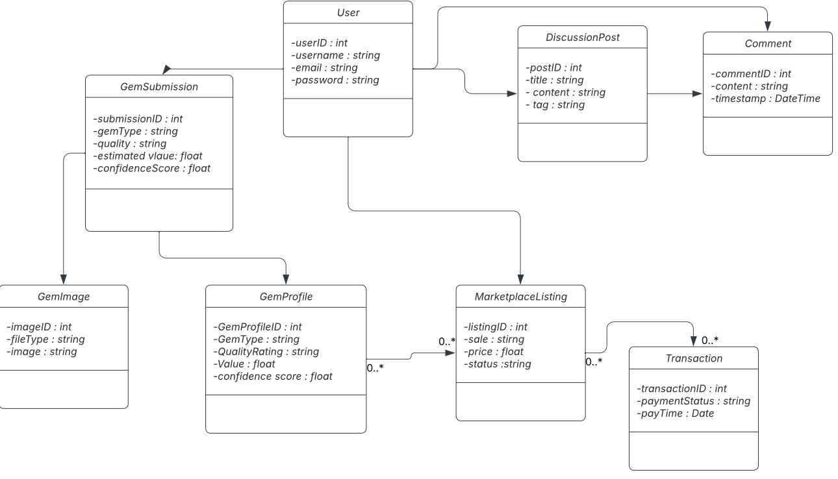
Figure 4 - UML Class Diagram
#DT-01: User Account Data
Description: Each user account shall store a unique user ID, username, email, password (hashed), and account activity history including gemstone analyzes, listings, purchases, and forum activity.
Rationale: The system needs persistent user data to associate actions such as gemstone uploads, marketplace listings, and discussions with the correct user.
Fit Criterion: In testing, each user account has a unique identifier, valid email format, and securely stored password. User-related actions (uploads, posts, purchases) must be correctly linked to the user account.
Acceptance Tests: DT-1, F-01, F-10

#DT-02: Gem Image Data
Description: The system shall store uploaded gemstone images along with metadata including file type, upload timestamp, and associated user ID. Accepted formats shall include standard image types (e.g., JPEG, PNG).
Rationale: Gemstone identification depends on accurate and valid image data, and each image must be traceable to a user and submission.
Fit Criterion: In testing, only supported image formats are accepted, images are stored successfully, and each image is linked to the correct user and submission record.
Acceptance Tests: DT-2, F-02

#DT-03: Gemstone Detail Data
Description: Each gemstone submission shall include structured data fields such as weight, size, color, and optional discovery information. Required fields must be validated before submission is accepted.
Rationale: AI identification and value estimation rely on both image data and structured gemstone attributes to improve accuracy.
Fit Criterion: In testing, required fields must be present and within valid ranges, and invalid or missing data results in rejection of the submission.
Acceptance Tests: DT-3, F-02, F-03

#DT-04: Gem Profile Data
Description: The system shall generate and store a gem profile containing gemstone type, quality rating, estimated value range, confidence score, and associated image and user data.
Rationale: The gem profile is the central data object used for user reference, marketplace listings, and further interactions in the system.
Fit Criterion: In testing, each analyzed gemstone produces a profile containing all required attributes, and the profile can be retrieved and displayed correctly.
Acceptance Tests: DT-4, F-03, F-04

#DT-05: Marketplace Listing Data
Description: Each marketplace listing shall include listing ID, associated gem profile, seller ID, price or bid format, listing status (active/sold), and timestamp.
Rationale: Listings must store enough structured data to support buying, selling, and browsing functionality in the marketplace.
Fit Criterion: In testing, each listing contains all required fields, is correctly linked to a gem profile and seller, and updates status after a purchase.
Acceptance Tests: DT-5, F-05, F-06

#DT-06: Transaction Data
Description: The system shall store transaction records including transaction ID, buyer ID, seller ID, listing ID, payment status, and timestamp of purchase.
Rationale: Transactions must be recorded to confirm purchases, track ownership changes, and support system accountability.
Fit Criterion: In testing, each completed purchase creates a transaction record with valid references to buyer, seller, and listing, and payment status is accurately recorded.
Acceptance Tests: DT-6, F-07

#DT-07: Discussion Post Data
Description: Each discussion post shall include post ID, user ID, title, content, timestamp, and optional tags (e.g., “Needs Identification”).
Rationale: Posts are necessary for enabling community interaction and knowledge sharing within the platform.
Fit Criterion: In testing, each created post contains all required fields and is correctly displayed in the discussion forum with accurate user association.
Acceptance Tests: DT-7, F-08

#DT-08: Comment Data
Description: Each comment shall include comment ID, post ID, user ID, content, and timestamp. Comments must be associated with a specific discussion post.
Rationale: Comments enable interaction between users and support collaborative identification and discussion.
Fit Criterion: In testing, comments are correctly linked to posts, displayed in chronological order, and include valid user references.
Acceptance Tests: DT-8, F-09

#DT-09: User History Data
Description: The system shall maintain a history of each user’s gemstone analyzes, listings, purchases, and forum activity, accessible through the user account.
Rationale: Users need persistent access to their past activity for tracking collections, reviewing transactions, and revisiting gemstone data.
Fit Criterion: In testing, all past user actions are stored and retrievable after logout/login, and records correctly reflect prior activity.
Acceptance Tests: DT-9, F-10

- Performance Requirements
12a Speed and Latency Requirements
#SL-01: Gemstone Picture Upload
Description: The amount of time it takes for an image of a gemstone given by the user to fully upload to the application and is ready to be analyzed by Amethyst’s gem identification tool.
Rationale: Users should be able to begin the gemstone identification process without long delays after selecting or capturing an image. Since image upload is the first step in generating a gemstone report, slow upload times may discourage use and make the application feel unreliable. A fast upload process improves usability and supports a smoother gemstone analysis experience.
Fit Criterion: For an image around 1 MB-10 MB in size (typical for Apple iPhones and Samsung Galaxys), the upload shall be completed within 5 seconds under a stable internet connection.
Acceptance Tests: SL-01

#SL-02: Gemstone Report Generation
Description: The amount of time it takes for the most recent model of the gemstone identification AI tool to generate a comprehensive report of the user’s gemstone from the uploaded picture.
Rationale: The gemstone report is one of the core functions of Amethyst. Users expect gemstone identification and valuation to be significantly faster than traditional appraisal methods. If report generation is too slow, the app loses one of its main advantages of providing accessible and fast gemstone analysis.
Fit Criterion: After a valid gemstone image has been fully uploaded, the application shall generate and display a comprehensive gemstone report within 10 seconds under normal operating conditions. The application shall display a loading indicator immediately after analysis begins.
Acceptance Tests: SL-02

#SL-03: Discussion Forum Refresh
Description: The amount of time it takes for the contents of the discussion forum and community feed to update with new posts from the users.
Rationale: Amethyst’s social and community feature depend on timely updates so users can view recent discussions, comments, and gemstone posts. This will encourage users to participate in discussions and cultivate an engaging and active gemstone community on the app.
Fit Criterion: When a user refreshes the discussion forum, the application shall display updated posts and comments within 3 seconds under normal operating conditions. Newly submitted comments shall appear to the posting user within 2 seconds.
Acceptance Tests: SL-03

#SL-04: Marketplace
Description: The amount of time it takes for the marketplace to load and display gemstone listings to the user.
Rationale: Slow marketplace loading times may discourage marketplace exploration and reduce marketplace activity.
Fit Criterion: The marketplace page shall display the first set of gemstone listings within 3 seconds under normal operating conditions.
Acceptance Tests: SL-03, SL-04

#SL-05: Listing Creation and Publication
Description: The amount of time it takes for a gemstone listing created by a user to become visible in the marketplace after submission.
Rationale: Sellers expect their listings to appear quickly so potential buyers can discover them immediately. Long delays may reduce seller trust in the platform and negatively affect marketplace participation.
Fit Criterion: After a user submits a gemstone listing with images and description, the listing shall appear in the marketplace within 5 seconds.
Acceptance Tests: SL-05

12b Precision or Accuracy Requirements
#PA-01: Gemstone Identification Accuracy
Description: The accuracy with which the AI gemstone identification system correctly identifies the type of gemstone based on the uploaded image and provided measurements.
Rationale: Accurate gemstone identification is a main function of Amethyst and thus users rely on the application to determine the correct gemstone type before making purchasing, selling, or valuation decisions.
Fit Criterion: The gemstone identification system shall correctly identify the gemstone type with at least 90% accuracy when tested against a verified dataset of labeled gemstone images.
Acceptance Tests: PA-01

#PA-02: Gemstone Valuation Estimate Accuracy
Description: The accuracy of the estimated market value provided by the gemstone valuation model compared to verified market values or expert appraisals.
Rationale: It is extremely important to accurately reflect the value of the user’s gemstone as users depend on it when buying or selling. The valuation must reasonably reflect real world market values to maintain trust in the marketplace.
Fit Criterion: The estimated gemstone value shall fall within ±15% of verified appraisal values for at least 94% of tested gemstones in the evaluation dataset.
Acceptance Tests: PA-01

#PA-03: Marketplace Listing Information Accuracy
Description: The accuracy of gemstone profile information displayed in marketplace listings.
Rationale: Marketplace trust depends on accurate and consistent gemstone information. Incorrect gemstone profiles may lead to misleading listings and reduced buyer confidence.
Fit Criterion: The gemstone profile displayed in a marketplace listing shall match the generated gemstone report with 100% consistency for all displayed attributes (gem type, estimated value, color, cut, clarity, and measurements). The user will still be able to set their own price, but the value the AI system estimated shall still be included in the listings.
Acceptance Tests: PA-02

12c Capacity Requirements
#CR-01: Gemstone Database Capacity
Description: Amethyst must be capable of storing and managing data for a large amount of unique gemstone records at launch.
Rationale: A 500,000 record capacity ensures system usability for at least a few years without necessitating a database upgrade.
Fit Criterion: Amethyst shall allow the user to upload, index, and retrieve the 500,000th record with no measurable reduction in data integrity.
Acceptance Tests: CR-01

#CR-02: Account Database Capacity
Description: Amethyst must support the storage and management of up to 50,000 active user accounts at launch. Each account record must include profile data, multi-factor authentication (MFA) settings, and a linked transaction history.
Rationale: To ensure Amethyst’s systems remain stable as the user base grows from initial launch to full market adoption. Centralizing this capacity ensures that authentication and authorization services don't bottleneck as more users are added to the platform.
Fit Criterion: Amethyst shall maintain a database of 50,000 concurrent user profiles at deployment.
Acceptance Tests: CR-02

#CR-03: Marketplace Listing Capacity
Description: The Amethyst marketplace must support up to 250,000 active listings by users at any given time.
Rationale: As users buy and sell gemstones on the marketplace, the number of listings will go up. It is important to make sure Amethyst’s marketplace can support a large volume of listings without limiting marketplace activity.
Fit Criterion: The system shall store and manage at least 250,000 active listings simultaneously with all listing data (images and gemstone report) being retrievable and displayed correctly.
Acceptance Tests: CR-03

#CR-04: Discussion Forum Post Capacity
Description: Amethyst’s must support up to 1,000,000 individual discussion forum posts.
Rationale: In order to preserve long term community knowledge, keep users engaged, and assist users with all of their gemstone queries, Amethyst must house years of readily available community interaction in the form of posts.
Fit Criterion: Amethyst’s systems shall allow for the creation of the 1,000,000th post without overwriting existing data.
Acceptance Tests: CR-04

- Dependability Requirements
13a Reliability Requirements
#RR-01: System Uptime Reliability
Description: An estimation of how long Amethyst’s systems will remain up and running without unexpected shutdowns or scheduled maintenance.
Rationale: Frequent downtime will disrupt marketplace transactions, negatively impact user experience with AI model and discussion forum, and overall reduce user trust.
Fit Criterion: The application shall run 99% of the time within a 30 day period excluding scheduled maintenance downtime.
Acceptance Tests: RR-01

#RR-02: Gemstone AI Analysis Reliability
Description: The rate at which the gemstone AI identification system produces valid and complete reports without failure.
Rationale: Since gemstone analysis is a core function of Amethyst, failed or incomplete reports would undermine the entire point of the application and reduce usability.
Fit Criterion: The AI identification tool shall successfully generate a complete gemstone report in at least 98% of analysis requests without any errors.
Acceptance Tests: RR-02

#RR-03: Data Integrity Reliability
Description: Amethyst’s ability to store and retrieve gemstone and marketplace data without corruption or loss.
Rationale: Data loss or corruption would severely impact trust and system credibility since users.
Fit Criterion: Amethyst’s systems shall maintain 100% data integrity for stored user accounts, gemstone profiles, and marketplace listings.
Acceptance Tests: RR-03

#RR-04: Failure Handling and Recovery
Description: Amethyst’s ability to handle failures gracefully and recover without significant disruption to the user.
Rationale: Amethyst must minimize user impact when a failure occurs and provide clear feedback instead of just crashing or freezing.
Fit Criterion: In the event of a failure, Amethyst shall display a clear error message within 2 seconds, prevent data corruption, and allow the user to retry the failed action.
Acceptance Tests: RR-04, RR-03

13b Availability Requirements
#AR-01: System Uptime
Description: The amount of time the Amethyst system is operational and available for users including marketplace, gemstone analysis, and discussion forum.
Rationale: High availability ensures users can access the platform when needed and maintains trust in the system.
Fit Criterion: The system shall maintain at least 99% availability over any 30-day period, excluding scheduled maintenance.
Acceptance Tests: RR-01

13c Robustness or Fault-Tolerance Requirements
#RFT-01: Offline Functionality
Description: The system’s ability to provide limited functionality when network connectivity is unavailable, including access to previously saved gemstone profiles, cached marketplace listings, and user account information.
Rationale: Users may access Amethyst in environments with poor or no internet connectivity. Providing offline access ensures continued usability and prevents total disruption of the user experience.
Fit Criterion: While some features will be unavailable such as the gemstone identification tool, marketplace, and discussion form as they require internet access, users shall still have access to their previously generated gemstone profiles.
Acceptance Tests: RFT-01

13d. Safety Critical Requirements
#SCR-01: Data Privacy and Encryption
Description: All sensitive data housed by Amethyst’s systems or databases that is to be protected and encrypted to prevent data leaks.
Rationale: It is extremely important to protect all user data and follow privacy laws for data collection. This will improve customer trust, increase Amethyst’s usability, and deter the company from any legal consequences.
Fit Criterion: All sensitive user data (accounts, gemstone profiles, transaction history, etc.) shall be encrypted and protected using standard encryption protocols.
Acceptance Tests: SCR-01, INR-01, PR-01

#SCR-02: Fraudulent Listing Detection
Description: The implementation of safeguards to detect and flag potentially fraudulent or misleading gemstone listings.
Rationale: Our customers are of great importance to Amethyst and it is essential that their safety and trust are prioritized. Fraudulent listings could financially harm buyers and damage the platform’s credibility thus drastically reducing Amethyst’s user base.
Fit Criterion: Listings with inconsistent or suspicious data shall be flagged for review or marked as unverified. If upon further review they are deemed fraudulent or potentially dangerous to buyers, the listing will be removed from the marketplace and the user that posted the listing will be notified of its removal.
Acceptance Tests: SCR-02

- Maintainability and Supportability Requirements
14a Maintenance Requirements
#MR-01: System Updates
Description: The system must support efficient updates and deployments with minimal disruption to users.
Rationale: Frequent updates may be required for fixing bugs or adding features.
Fit Criterion: The update process shall be streamlined to avoid long downtime or complex procedures. System updates shall be deployable with no more than 10 minutes of downtime.
Acceptance Tests: MR-01

#MR-02: AI Model Updates
Description: The system will allow the gemstone identification AI model to be updated requiring major changes to the application.
Rationale: As AI models improve over time, it is important for Amethyst to support easy model updates to maintain or improve accuracy.
Fit Criterion: The AI model shall be updatable or replaceable without modifying other system components or requiring a full redesign of the entire application.
Acceptance Tests: MR-01, MR-02

14b Supportability Requirements
#SR-01: In-app Informational Support
Description: Helpful information that may be helpful to users including tutorials, tooltips, and help guides that explain key features such as gemstone analysis, marketplace usage, and account management.
Rationale: Providing built-in guidance reduces user confusion. This would be especially useful for new users unfamiliar with gemstone terminology or app features.
Fit Criterion: The application shall include accessible help documentation within the app, tooltips or explanations for key features that will be denoted by the symbol ⓘ, and a searchable help or FAQ section.
Acceptance Tests: UD-01, SR-01

#SR-02: Discussion Forum
Description: Users can utilize Amethyst’s discussion forum and ask questions, share knowledge, and assist each other with gemstone identification, valuation, and marketplace interactions.
Rationale: A community driven support system allows users to help one another, and foster engagement within the platform. This would also reduce the demand for any external help in the form of support tickets and the like.
Fit Criterion: Amethyst’s discussion forum shall be used to allow users to create posts and comments, display posts in real time or near real time support moderation or reporting of inappropriate content
Acceptance Tests: SR-02, SL-03

#SR-03: Bug Report Feature
Description:A built in feature that allows users to report bugs or technical issues directly from the application. The reports will then be reviewed and subsequently resolved by developers and Quality Assurance Engineers.
Rationale: User reported bugs help developers identify and resolve issues more quickly thus improving system reliability and user experience.
Fit Criterion: The bug report feature shall allow users to submit bug reports with descriptions and automatically include relevant system data (app version or device type).
Acceptance Tests: SR-03

14c Adaptability Requirements
#ADR-01: Cross-Platform Compatibility for Mobile
Description: The ability for the Amethyst app to fully operate on multiple mobile operating systems.
Rationale: To reach a broad user base and maximize user engagement with the app, the application must be accessible on the most widely used mobile platforms.
Fit Criterion: The Amethyst application shall run on both iOS and Android mobile operating systems with the earliest versions being iOS17 and Android Upside Down Cake.
Acceptance Tests: ADR-01

14d Scalability or Extensibility Requirements
#SER-01: User Base Scalability
Description: Amethyst’s ability to scale to support an increasing number of users without requiring significant architectural changes or app redevelopment.
Rationale: As the platform gains popularity among gemstone collectors and marketplace users, the number of active users will grow. The system must scale efficiently to maintain performance and usability.
Fit Criterion: The system shall support scaling by increasing system resources like server size and database capacity without requiring a major app redesign.
Acceptance Tests: SER-01

#SER-02: Feature Extensibility
Description: The support of new additional features such as new analysis tools, marketplace enhancements, and social features.
Rationale: It is important for Amethyst to evolve over time with new features. A flexible system design allows for efficient expansion and reduces development time for new features.
Fit Criterion: New features shall be implemented as independent modules or services without modifying existing core components thus not warranting a major app redesign.
Acceptance Tests: SER-02, MR-01, MR-02

14e Longevity Requirements
#LR-01: Data Preservation
Description: The long term storage of user data such as gemstone profiles, marketplace, listings, and transaction history.
Rationale: Inaccessibility or failure to obtain a user’s data after a long period of time could result in loss of usability or trust by the user.
Fit Criterion: Amethyst shall retain all data and have it be accessible for years with appropriate backup and recovery mechanisms in place. The user data may be permanently deleted only if the user explicitly requests it, after 5 years of account inactivity, or when the data is no longer required for operational or security purposes.
Acceptance Tests: LR-01

#LR-02: System Lifetime
Description: The Amethyst system must be designed to remain operational, maintainable, and relevant for long-term use. It must support continuous updates, performance improvements, and feature enhancements without requiring a complete system redesign.
Rationale: Amethyst is intended to serve as a long-term platform for gemstone analysis, marketplace transactions, and community interaction. A system with a substantial and well defined operational lifetime ensures that users can rely on the platform to store and access their data over time while at the same time reducing redevelopment costs and supporting system scalability.
Fit Criterion: At launch, Amethyst shall operate effectively for a minimum of 5 years. During this time, the application shall receive regular software updates, receive regular AI model updates, and ultimately avoid the need of a complete system replacement.
Acceptance Tests: LR-02, SER-02

- Security Requirements
15a Access Requirements
#ACR-01: Regular Users
Description: Regular Users have access to most features across the application in Read permissions, with some Write and Execute permissions according to necessary functions as the AI Identification form or posting on Discussions. These users DO NOT have the ability to edit the Catalogue, nor the posts and listings of other users/businesses within the Marketplace and Discussions page aside from their own postings and comments.
Rationale: Regular uncertified/untrusted users should not have the ability to change displayed content as it is a risk of spreading misinformation and/or mislabeling opinion as fact.
Fit Criterion: Only ability to edit Identification request forms (both AI and Expert), and their own postings and comments/reviews on Marketplace and Discussions. Everything else is Read Only.
Acceptance Tests: ACR-01

#ACR-02: Business Users
Description: Business Users are the seller/commercial accounts that mainly utilise the Marketplace as a means to advertise their offers of gemstones for sale. On top of Regular User permissions, they have the ability to create, edit and delete their own listings on the market, and may have access to special features to help manage their shipping and returns in future updates. Business accounts are created by signing up with the app to share additional information on their type of business, locations, focus, etc, and may include other users as “moderators/customer service representatives” under their account.
Rationale: Business accounts should have wider control of their own presence on the Marketplace, but it does not mean they can change any listings that are not tied to their account.
Fit Criterion: Additional ability to create, edit and delete their own listings on the Marketplace, and share this ability with listed users under their shared group.
Acceptance Tests: ACR-02

#ACR-03: Trusted Industry/Field Experts
Description: Trusted Industry/Field Experts are certified users working under geology related industries and scientific communities that will work closely with moderation teams to assess the gemstone Catalogue and AI Identification for accuracy and rewrite facts listed for clarity and truth. In addition to the permissions of Regular Users, these accounts can access the full extent of the catalogue (including any unreleased updates) in read only. Should they encounter an error or misinformation, they are able to directly connect with the moderation team (direct chats) with evidence and discuss corrections. They are also listed with a mark on their accounts (similar to the verified mark on Twitter/Facebook) should they appear in the Discussions page.
Rationale: Industry & Field Experts are able to verify information with evidence, but should not be able to rewrite it directly themselves as to limit risk of tampering (whether accidental or intentional) by the user, or someone else pretending to be the user (hackers).
Fit Criterion: App allows this user to access any version of the catalogue, and has a direct connection to the moderation team to verify information and make corrections.
Acceptance Tests: ACR-03

#ACR-04: Moderators
Description: Moderators are members of the maintenance team that provides regular servicing to the application after release, ensures proper updates, verifies information with industry/field experts and monitors user feedback. These users have access to any part of the application as needed (read, write, and execute permissions may be switched on and off depending on the part of the application and what their current job requires), determined by the managers of the maintenance team.
Rationale: Some Moderators may specialize in monitoring and maintaining certain parts of the application (such as Discussions) and may not need full access to other parts (such as the Catalogue in this case).
Fit Criterion: Access to read, write, and execution outside the permissions of a Regular User are able to change, and is reflected in attempts to access such content.
Acceptance Tests: ACR-04

#ACR-05: Probe Accounts
Description: Probe Accounts are replaceable accounts set up through a virtual machine by and for the Moderation Team. They are particularly meant to be used for checking file uploads by users during an approval process to make public postings in the Marketplace and Discussion pages. These accounts are expected to come into contact with viruses, worms, and other attacks and are meant to be easily killed and replaced.
Rationale: Allows the moderation team to detect malicious attacks by users without risking access to the entire system (detection damage is limited to the virtual machine environment).
Fit Criterion: Created within a virtual environment, managed by the moderation and maintenance team, and has the ability to access pending posts. Easily replaceable.
Acceptance Tests: ACR-05

15b Integrity Requirements
#INR-01: Catalogue Data Security And Integrity
Description: The Catalogue database should only be allowed to be reviewed by both Industry/Field Experts and Moderators, and only be edited by Moderators. Versions of the database should be controlled by Version Control on the cloud and servers, and fully tested and approved versions by quality assurance teams should have a copy stored on physical hard drives that are stored in multiple different locations, just in case one should fail or be compromised.
Rationale: Mitigation of risk of corruption, misinformation and unregulated change to existing active gemstone databases while also having additional copies saved in multiple locations as backups should problems arise in any.
Fit Criterion: Testing of access controls listed in 15a (ACR-03, ACR-04) and saving of database on cloud storage, server, and disconnected hard-drives.
Acceptance Tests: ACR-03, ACR-04, INR-01

15c Privacy Requirements
#PR-01: Personal User Data
Description: Personal User Data displayed and saved on their own Home page should mostly be only accessible by the user. There are cases where the user may be required to share or allow access to this data such as transaction and address data for making purchases on the Marketplace, or for investigation and fixes by Moderators should their account be breached or leaked.
Rationale: Most users outside the service should never be able to have any or full access to another’s personal data. Only specific users in specific cases should be able to access partial data. Otherwise if required, service teams can request access from the user, but it is ultimately up to the user to share their data or not.
Fit Criterion: Users can never view other users data. Business accounts may request banking information and address from other users who seek to make a purchase. Moderation teams may request access to specific user data when it is required to fulfill their tasks only.
Acceptance Tests: PR-01

15d Audit Requirements
#AUR-01: Marketplace Transactions
Description: Marketplace transactions should have tracking for payment and package. It can be monitored by both seller and buyer and should follow the standard operations of major online sellers like Amazon (buyer makes payment that is held by third party bank/company → seller ships package → seller receives payment). This may require additional assistance and recommendations by banks for steps and security requirements.
Rationale: Allows every party involved to track the transaction and gemstone package, and details are stored in case there happens to be any involvement in fraud. Details can be used by government authorities and the law in such cases
Fit Criterion: Details and UI on the states of the transaction such as amount, buyer, seller, date, time, etc are stored and displayed to all parties involved.
Acceptance Tests: AUR-01

15e Immunity Requirements
#IMR-01: Form Security
Description: All forms including but not limited to Account Registration, AI Gemstone Identification, Marketplace Purchase, and Discussion Posts should follow standard security recommendations according to their nature (i.e. Marketplace purchase may need tighter security than a Discussion Post). These particularly aim to prevent injection attacks or linking files and images that may contain a virus, worm, Trojan attack, etc. Public postings like Discussion Posts should be reviewed by a moderation team probe account before being released on the main site.
Rationale: This aims to protect both the site and other users from malicious attacks through any means of input as files, images and links. Probe accounts by the moderation team can be made in a virtual environment so as to contain any damage caused by discovering an attack.
Fit Criterion: Form inputs prevent injection attack attempts and probes scan through file uploads.
Acceptance Tests: ACR-04, ACR-05, IMR-01

- Usability and Humanity Requirements
16a Ease of Use Requirements
#EUR-01: User Interface / User Experience Requirements
Description: Users younger than 50 have no trouble navigating the app on their own. No manual is required, but one should be available in a Help section. Each page should follow common design choices and layouts from existing applications that function similarly.
Rationale: Marketplace and Discussions should feel familiar to users as they have the same UI layout as other apps of similar function (Amazon, Twitter, etc). The Catalogue will have a similar layout to a news website and the Gem Identification will be a form, which may need some help understanding initially.
Fit Criterion: Test completed first release on people of varying age groups. Gather feedback through surveys. Document comments, findings and rework the UI as needed.
Acceptance Tests: EUR-01, LER-01

16b Personalization and Internationalization Requirements
#PIR-01: Location-Based Personalization
Description: Given permission to access location, the app should detect which country and thus, language and currency symbol to display in its UI. This should be checked when the user first signs up for an account, and will remain the same until the user changes it in settings. If unable to access location data on signup for whatever reason, then default to English and currency in USD ($).
Rationale: This adaptability is expected by users on international applications, and should be followed. Default will also follow common practice and use English.
Fit Criterion: Automatic detection of location and applies settings upon account setup. Default tested by forcing unallowed app-permissions to access location data.
Acceptance Tests: PIR-01

#PIR-02: Account Personalization
Description: Standard account personalization. Includes profile, personal details, shipping address, links to social media accounts, etc.
Rationale: Standard account customization shared across many applications. This app should do the same.
Fit Criterion: UI layout and method of profile customization should feel familiar and intuitive upon first look for new users.
Acceptance Tests: PIR-02

16c Learning Requirements
#LER-01: First User Friendly
Description: Users younger than 50 should be able to intuitively understand and learn navigation and each of the application’s functions on their own. No manual is required, but one should be available in a help section. Each page should have its own little help button that shows a short tutorial on what is on the page and what each button/bar does. This should be in the form of step-by-step illustrations so as to not overwhelm the user.
Rationale: The application as a whole should be designed intuitively so users can navigate and use on their own, but help functions should be available and easy to find should they need it
Fit Criterion: Test completed first release on people of varying age groups. Gather feedback through surveys. Document comments, findings and rework the UI as needed.
Acceptance Tests: EUR-01, LER-01

16d Understandability and Politeness Requirements
#UPR-01: Simple English / Words Standardization
Description: All parts of the program that display output (not written by a human at that time) should use simple standard wording, particularly in English. No long, complex, and uncommon words that many people may not understand.
Rationale: To avoid confusion as much as possible, and for the users comfort when using the app.
Fit Criterion: Usage of common everyday words depending on the language. Minimum usage of long complex words and phrases as possible.
Acceptance Tests: UPR-01

16e Accessibility Requirements
Not Applicable

16f User Documentation Requirements
#UD-01: Digital User Help Manuals
Description: Help options should be available on every major page on the application, tailored to guide users on what the page is, and how they can use it. A complete user manual should be accessible in a help button near settings, composed of all help manuals scattered throughout the pages.
Rationale: On each page, a user may only require specific information and help regarding how they can understand and use that particular page’s functionality. A complete version should still be available in the menu bar.
Fit Criterion: Main manual in the Menu bar, and specific sections linked on their respective related pages of the application.
Acceptance Tests: UD-01

16g Training Requirements
#TR-01: Industry/Scientific Community Fact Checkers Training
Description: Because the accounts of verified experts have access to the catalogue, and are expected to answer questions in the discussions page as a secondary task, they can be given some starting training for fulfilling their role using the app. This will include teaching them about their expanded abilities, what they are expected to do on the application in their own time, and examples of how to do so.
Rationale: Without any formal training, partnered experts may be confused over their expected duties and how to do them properly. Formal training should give them a good foundation to conduct their work, and give them confidence to meet both other experts, and the wider community through the app.
Fit Criterion: Group/one-on-one training with a developer to guide them on how the app and their permissions work, including demonstrations and activities. Provide direct connections to both development and moderation teams after for their convenience.
Acceptance Tests: ACR-03, TR-01

- Look And Feel Requirements
17a Appearance Requirements
#APP-01: Colour & Font Scheme
Description: The main colours of Project Amethyst pages should be as follows:
- Menu Purple: 8206C3
- Menu Button Border: 4E0679
- Header Bar Purple: 50009A
- Notification Purple: 6600CC
- Scroller Grey: DDDDDD
- Box Grey: D0D0D0
With solid white as the background (FFFFFF). Tahoma is used for the text style at size 12, normal for general text, and bold for buttons, headers, and short text at varying sizes from 12 to 16. With purple backgrounds, white (FFFFFF) is used, and black (000000) for text on white background. Prompts within input use the same style and font, but are coloured grey (A4A4A4).
Rationale: Consistent and intuitive styling of text allows for ease of reading and understanding. Highlighting differentiates important and interactable assets (buttons, scrolling, etc) from ordinary text. Background colour styling fits with the colour scheme around Project Amethyst (purple-white shades).
Fit Criterion: Colour and text schemes are consistent in colouring, styling and fonts to the provided RGB hex values. Example wireframes for the Identification, Catalogue, Marketplace, Discussions and Menu are provided in Section 25f, User Interface.
Acceptance Tests: APP-01, STR-01

17b Style Requirements
#STR-01: Familiar Professional Styling
Description: Because the application itself has various pages whose functions are similar to wider known apps, styling and design of the page layout should not differ much to keep a familiar feel for users, but colours and fonts should follow that set in Appearance Requirements (APR-01) above to keep a unique image of Project Amethyst.
Rationale: This allows for pages as Marketplace and Discussions to feel already familiar to most users, and hence easier to use, while keeping to Project Amethyst’s signature purple and white colouring.
Fit Criterion: Follow the wireframes provided in Section 25f, User Interface.
Acceptance Tests: APP-01, STR-01

- Operational And Environmental Requirements
18a Expected Physical Environment
#EPE-01: Local Smartphone / Tablet Operations
Description: The application would function on a smartphone and tablet like any other mobile application, tailored for both IOS and Android operating systems. Only data stored locally are meant for running the application (RAM services). A part of the AI Identification system may be available with a smaller locally stored database for offline use, but this may mean its accuracy and details will be limited.
Rationale: The application should not take up too much space and be processor nor memory intensive. Most services may not be available without an internet connection, but a local AI Identification software may still function to a limited extent.
Fit Criterion: Local download at around 5 GB, and should not take up more than 10% performance of memory, CPU, etc, at a time. Local offline Identification is not a priority, but may be a further update.
Acceptance Tests: SL-01, SL-02, EPE-01

#EPE-02: Cloud / Server Operations
Description: Services for the application are provided by physical or cloud servers and storage. These consist of the GPUs needed for thorough AI Identification, storage and access to the Catalogue database, and up-to-date postings for the Marketplace and the Discussions page.
Rationale: Servers may handle the bulk of processing and responding to requests. The cloud may be used to expand and constrict to meet demand in the application’s alpha and beta release stages.
Fit Criterion: Response handling times are within reason (few seconds maximum aside from the AI Identification) and respond with up-to-date information across pages.
Acceptance Tests: SL-01, SL-02, SL-03, SL-04, SL-05, EPE-02

18b Requirements for Interfacing with Adjacent Systems
#IAR-01: Links To Other Apps And Websites
Description: Postings on the Marketplace and Discussions may lead to other apps and websites such as a seller’s main website, seller’s Amazon site, or a related video on YouTube. These links should work as expected in opening said applications unless there are connection issues (no WI-FI).
Rationale: Users may want to share links to media or shops on other platforms for other users to see.
Fit Criterion: Links open within a few seconds and do not close the Project Amethyst app, but let it run in the background at decreased processing and memory usage.
Acceptance Tests: IAR-01

18c Productization Requirements
#PR-01: Distribution Platform
Description: The application should be accessible through either the Apple App Store or Google Play Store platforms.
Rationale: Many users whether they have an Apple device or Android Device should have access to the application ensuring broad market reach and accessibility.
Fit Criterion: Application should be searchable in both the App Store and Google Play Store, users should also be able to download the latest version without errors.
Acceptance Tests: PR-01

18d Release Requirements
#RER-01: Structured Release Cycle
Description: Every few months there will consist of updates to the application. This will include AI updates, marketplace and community forum updates for quality of life. Most updates will be based on feedback from users.
Rationale: Regular updates will ensure continuous improvement and satisfaction of user experience. A regular release cycle also helps maintain user engagement and trust in the application allowing for timely fixes to bugs or quality of life improvements.
Fit Criterion: Updates every month whether they are major or minor. Each update will include version number and details of the changes made with the new update. Updates will be successfully published through Apple and Android platforms.
Acceptance Tests: RER-01

- Cultural And Political Requirements
19a Cultural Requirements
#CUR-01: Inclusive and Accessible User Experience
Description: The application shall provide inclusive and culturally appropriate user experiences that accommodates diverse backgrounds, including varying levels of gem knowledge. This product shall support multiple languages, culturally neutral imaging and ensuring discussion forum content adheres to community guidelines that respect cultural diversity.
Rationale: This application targets a global audience interested in gemstones, this includes collectors, jewelers, and casual hobbyists. Cultural inclusivity and accessibility increases user engagement in discussion forums, and ensures respectful interactions in the marketplace.
Fit Criterion: The application supports at least two languages. User interface elements are reviewed for cultural appropriateness. Discussion forums include guidelines that prohibit hate speech, discrimination, or culturally offensive content. The application should also be usable for novice and experienced gem enthusiasts, with clear instructions and accessibility.
Acceptance Tests: CUR-01

19b Political Requirements
#POR-01: Compliance with Platform and Stakeholder Policies
Description: This application shall comply with all platform policies and guidelines set by the distribution platforms, and stakeholder requirements such as branding consistency, and data handling processes. This includes content moderation standards for discussion forums and transaction policies for the marketplace.
Rationale: Compliance with platform and stakeholder requirements is necessary to ensure the application is approved for distribution. This avoids removal from platforms and penalties, and aligns with business goals set by stakeholders.
Fit Criterion: The application passes Apple and Android platform review processes without rejection due to policy violations. All branding elements align with stakeholder guidelines. Marketplace transactions and user content comply with platform rules and expectations.
Acceptance Tests: POR-01

- Legal Requirements
20a Compliance Requirements
#COR-01: Data Privacy and Protection
Description: This application will comply with all applicable data privacy and consumer protection laws and regulations, including the collection, storage, and use of user data from the AI camera, marketplace transactions, and discussion forums. This includes obtaining user consent, providing clear privacy policies, and ensuring the secure handling of personal and transactional data.
Rationale: This application collects user data through the use of AI cameras, account information, and marketplace activities. Compliance with legal standards protects user privacy and reduces legal risks. Failure for compliance could result in penalties, app removal, and distrust in the application.
Fit Criterion: A clear and accessible privacy policy within the application. Users must also consent to data collection before using certain features of the application. User data is securely stored and transmitted using industry standard encryption methods. The application also needs to comply with relevant regulations and pass internal and external legal review prior to release.
Acceptance Tests: COR-01

20b Standards Requirements
#STD-01: Application and UI/UX Standards
Description: This application shall conform to the established application development and user interface standards. This includes platform-specific design guidelines, accessibility and secure coding practices. This applies to all core features of the application.
Rationale: Adhering to recognized standards will ensure a consistent, intuitive, and high quality user experience across all platforms. It will also improve usability, accessibility, and maintainability while reducing development errors.
Fit Criterion: The application interface follows Apple and Android guidelines. This application meets basic accessibility standards. The code adheres to secure coding and development standard practices. UI/UX consistency is verified across all major features and platforms.
Acceptance Tests: STD-01

- Requirements Acceptance Tests

21a Requirements - Test Correspondence Summary
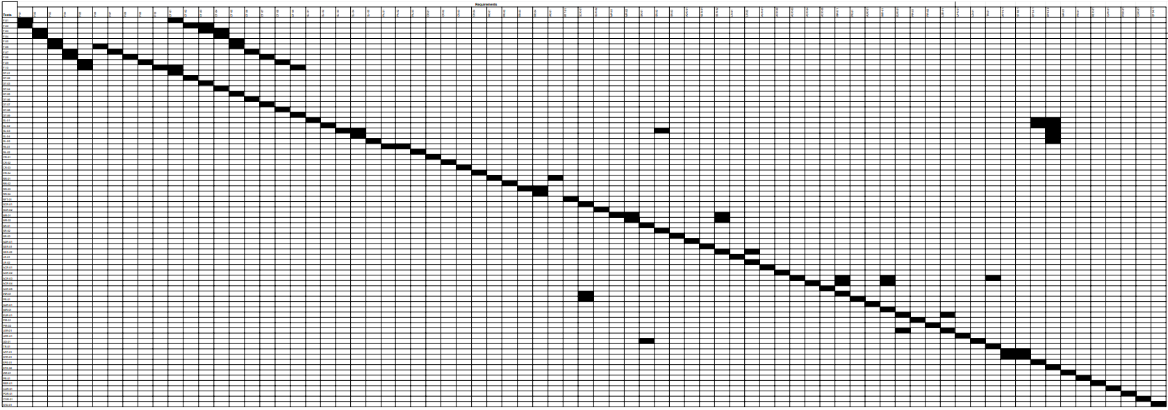
Table 4 - Requirements Correspondence

21b Acceptance Test Descriptions
#F–01: Account Login
Description: Checks and verifies for valid account in database. If there is a match it will redirect into the main page of the application. If invalid credentials it will prompt an incorrect credentials message.
#F–02: Upload Gem Image and Details
Description: Checks for compatible image type. Then if it is compatible it will check if every required box of information is filled in, in order to attempt recognition of a gemstone.
#F–03: AI Gemstone Identification
Description: Attempts to identify gem if valid inputs were obtained from user. Checks database for similar gemstones if there are any close matches it will show a confidence level of what the AI thinks the gemstone is. If it is not in the database it will show alternatives of what it could be and suggests discussion in the forums.
#F–04: Generate Gem Profile and Estimate Value
Description: Checks for matches in the database to the images and information given by the user. It should return a confident assumption of the gemstone and an estimated value in the local currency.
#F–05: Marketplace
Description: Users should be able to publish a listing for a gemstone they are selling. Listing should be visible to all users using the application and be interactable.
#F–06: Browse and View Marketplace Listings
Description: Users should be able to view multiple listings of gemstones and interact with any of them. The listings should be filterable through location or specific gemstones if the user wants to narrow down the search.
#F–07: Purchase Gemstone
Description: Users should be able to purchase a gemstone through a listing. The application should record the transaction and charge the user through their account and should get a confirmation for their purchase.
#F–08: Create Discussion Posts
Description: Users should be able to publish a post and have it visible to every user in the application. The correct tags and title should be published with the post and visible to all users.
#F–09: Comment on Discussion Posts
Description: Users should be able to interact with multiple discussion posts and comment in the thread. Users should be able to interact with one another through commenting in threads and being able to see each other's messages.
#F–10: Save User Gem History
Description: User history of AI Gemstone Identification should be accessible at any time. Previous uses of the AI feature should have the results saved into the account history and be accessed correctly.
#DT–01: User Account Data
Description: User ID, username, email and password will be stored in the database. Every action will be recorded and linked to the corresponding account number. Each user should have their own unique account number with no overlaps.
#DT–02: Gem Image Data
Description: Valid image formats should be verified. If not a valid format it will be rejected. The image should be saved and linked to the user's unique account number.
#DT–03: Gemstone Detail Data
Description: Every information required should be entered with the valid data ranges. If not every box of information is filled out the AI Identifier will not start its operations.
#DT–04: Gem Profile Data
Description: Data entered should follow data types and ranges according to the detail. Cases such as negative pricing and weight, invalid image types and non-text entries as emojis should be rejected.
#DT–05: Marketplace Listing Data
Description: Listings created should display the correct data, image, text and availability status. Only the listing ID needs to be displayed, and other IDs may remain hidden.
#DT–06: Transaction Data
Description: Transaction data should only exist in the history between the buyer and seller (and moderator/customer service should they be needed). Only transaction ID, amount paid, time, and status and product need to be shown. Others such as buyer ID and seller ID are hidden but exist in the relevant database table instance.
#DT–07: Discussion Post Data
Description: Check that the post displays the username, title, timestamp, post tags, and content including any attached images and links. UserID and Post ID should not be displayed publicly but exists as part of the post instance in the relevant database table.
#DT–08: Comment Data
Description: Check that comments made on a post contain the relevant information as username, content and timestamp of the post. User ID, Post ID and Comment ID should not be visible on public view but exists in the attributed database as an instance.
#DT–09: User History Data
Description: After testing other parts such as transactions, purchasing, gem identification and so on, relevant information should be displayed in related pages, and a summary of the user activity on the Home page.
#SL-01: AI Image Upload
Description: Verify that an image of size 1MB to 10MB uploaded by the user to Amethyst is fully processed and available for analysis within 5 seconds. This is done by starting a timer at the same time the user selects “upload” and stopping it when it shows the image was successfully uploaded and is ready for analysis.
#SL-02: Gem Profile Generation
Description: A full comprehensive profile of a user’s gemstone is created in 10 seconds or less by analyzing the image of the gemstone given by the user. The profile should have attributes such as type, color, cut, clarity, value, etc. Upload a valid gemstone image, start a timer at the start of the analysis, and stop the timer when the profile generation is complete. Verify that all attributes are present and valid and that it took no longer than 10 seconds.
#SL-03: Refresh Speed
Description: Under normal operations, it should take on average 3 seconds or less for the app to update its content with new information and present it to the user. To verify this test, a screen of refreshable data is presented and upon refreshing a timer is started. When the updated content is visible, we stop the timer and check if it took no longer than 3 seconds.
#SL-04: Marketplace Startup
Description: Upon opening up the app’s marketplace, the user should see current and valid listings within 3 seconds. To verify this, we start a timer when the marketplace is selected and check if it took no longer than 3 seconds to present updated marketplace listings.
#SL-05: Listing Publication Speed
Description: A user should be able to create a listing for a gemstone they would like to sell using the information in the profile generated by Amethyst. After creating the listing, the listing should appear to other users on the marketplace within 5 seconds. To verify this, we have two separate accounts: one that will create the listing (account A) and another one that will refresh the marketplace to check if the listing has appeared in 5 seconds or less.
#PA-01: Gem AI Accuracy
Description: The accuracy at which the AI gemstone identification system correctly identifies the type, value, cut, clarity, and any other pertinent information about the gemstone using only an image given by the user should fall within 90% accuracy when compared against a previously verified data set of gemstones. We run the AI system on every gemstone in the database and compare them against an already verified dataset of gemstones.
#PA-02: Marketplace Listing Information Accuracy
Description: When a user creates a marketplace listing, the displayed information should reflect the gemstone profile generated by the AI analysis system with 100% accuracy. To test this, we generate a gemstone profile, create a marketplace listing using the same information in the profile, and compare them to each other.
#CR-01: Gem Profile Capacity
Description: Amethyst’s database should house around 500,000 unique gemstone profiles generated by the AI gem identification system. We verify insertion success on the 500, 000th entry and retrieve random entries to check for corruption or data loss.
#CR-02: Account Capacity
Description: Amethyst’s database should be able to house around 50,000 unique user accounts. Each account must be equipped with a user ID, Email Address, and password. Also, each account should have the ability to have gem profiles and transaction history attributed to it. Simulate 50,000 accounts into the database and check if each account has the required attributes.
#CR-03: Marketplace Listing Capacity
Description: The Amethyst marketplace is able to house around 250,000 marketplace listings simultaneously. Each listing should have data such as images, date created, etc. We verify this by inserting 250,000 active listings into the marketplace and check if each one has the required fields.
#CR-04: Discussion Forum Post Capacity
Description: Amethyst will house 1,000,000 individual discussion forum posts. This includes any comments under the post made by other users. To check this, we insert a million posts to the discussion forum and check if each post can have comments, upvotes, and downvotes.
#RR-01: System Uptime Reliability
Description: Amethyst’s systems remain fully operational for at minimum 99% of the time within a 30 day period. This excludes any scheduled maintenance downtime. Systems included are the AI gem identification tool, marketplace, discussion form, and user account home. To verify this, we monitor the system for 30 days and log any outages aside from scheduled maintenance.
#RR-02: Gemstone AI Analysis Reliability
Description: Valid and complete profiles that are generated by Amethyst’s gem identification tool. Profiles can not be generated with missing or incomplete data; all attributes must be accounted for. If a complete profile can not be generated, the system should notify the user of the failed generation. To verify this, we have two datasets of gemstone images: a set of valid images and a set of invalid images. We upload the images to the gem AI system and verify that the valid images create gem profiles that have all valid attributes and the invalid images notify the user of a failure to create the profiles.
#RR-03: Data Integrity Reliability
Description: Amethyst is able to store and retrieve data without the data being lost or corrupted. This extends to user data, gemstone profiles, marketplace listings, and transaction history. To verify this, we create accounts with user data, save them in the database, retrieve them later, and compare the results of the retrieved data to the original data.
#RR-04: Failure Handling and Recovery
Description: System failures are gracefully handled and recover without any significant disruption to the user experience. System functionality and data integrity is persevered. We simulate failures such as AI service failure, loss of internet connection, or a server crash to verify this test.
#RFT-01: Offline Functionality
Description: Users still have access to certain features such as gemstone profiles, cached marketplace listings, and user account information. Features such as the marketplace, discussion forum, and the gem AI tool should not be available for offline users and will require internet access. We test this by first using the app while it is online, then disconnect from the internet and try viewing our saved gemstone profiles and account information. We will also verify that we are unable to use the features that require internet service.
#SCR-01: Data Privacy and Encryption
Description: Verify that all data transmitted between the client and server is encrypted using secure protocols such as HyperText Transfer Protocol (HTTPS).
#SCR-02: Fraudulent Listing Detection
Description: Marketplace listings should be verified for authenticity. Potentially harmful or fraudulent listings should be flagged and reviewed by quality engineers. If after review they are deemed fraudulent, they should be removed from the marketplace entirely and the user who originally posted the listing should be notified. We verify this by creating a listing that is intentionally fraudulent and post it to the marketplace. We check that the system flags the post and the post is sent for further review.
#MR-01: System Updates
Description: Verify that the entire system is updatable. The updates must cause either minimal disruption to users or no disruption to users.
#MR-02: AI Model Updates
Description: Amethyst’s AI gem identification tool should be either updatable without requiring any major architectural changes to the application. We verify this by updating the AI system and seeing if the rest of the app remains fully operational with the new system in place.
#SR-01: In-app Informational Support
Description: The app needs to provide easily accessible help documentation such as an FAQ section or user instruction manual that presents clear instructions on how to use each feature to its users within the app. Furthermore, the interface should include ⓘ symbols placed next to common points of confusion which users can select to view brief explanations or guidance. We verify this by making sure when a help manual and FAQ section is accessible from the home screen when opening the app and when users visit screens that have common points of confusion, the ⓘ symbol is displayed. When the symbol is clicked, helpful guidance text should appear.
#SR-02: Discussion Forum
Description: Users can utilize the discussion forum for any queries they may have about either Amethyst itself or gemstones and gemology. This will offer real time support to users.
#SR-03: Bug Report Feature
Description: Users can report any bugs or technical issues they’ve discovered within the app. The report should have some data points such as the version of the application and the device type at the time of the report.
#ADR-01: Cross-Platform Compatibility for Mobile
Description: Amethyst needs to be compatible with iOS and Android OS (the earliest versions being iOS17 and Android Upside Down Cake). The app must be fully operational on both operating systems. We will verify this works by downloading the app on both systems (iOS and Android) and test that all critical features work on both platforms.
#SER-01: User Base Scalability
Description: Simulate a growing number of active users on the Amethyst platform and verify that the system continues to function correctly as additional server and database resources are added. There should be no redevelopment of the application. We will simulate an increasing number of users on the platform (1,000, 5,000, 10,000) and test latency and system performance to verify this requirement.
#SER-02: Feature Extensibility
Description: Amethyst’s system architecture should support the addition of new features, services, or tools without requiring major modification of existing core components. We will add a new feature to the app and check which features are changed (if any exists) to verify this.
#LR-01: Data Preservation
Description: Verify that user data, including gemstone profiles, marketplace listings, and transaction history, remains stored and accessible after an extended retention period. To verify this, we will create user accounts with user data in them and either store them for a long period of time or simulate long time storage after which we will compare the original data.
#LR-02: System Lifetime
Description: Verify that the application will maintain functionality over a long period of time (5 years) and can receive constant updates without completely breaking.
#ACR-01: Regular Users
Description: Access to all major functions on the application including Identification, Catalogue (Read-Only), Marketplace and Discussions. Can edit own personal details and manage accounts in the Home menu, and settings.
#ACR-02: Business Users
Description: On top of Regular User permissions, Business Accounts can create a seller platform on the Marketplace, list items for sale with details and add other users to help manage their market platform. Additional details about the business and legality requirements, etc must be signed and approved by the Moderators before Business account conversions.
#ACR-03: Trusted Industry/Field Experts
Description: On top of Regular User permissions, Expert Accounts gain special access to the gemstone database tied to the Catalogue and AI Identification in read only (possibly suggest permissions like in text editors). These accounts go to only verified experts trusted by the moderation and development team, and should have direct connections with both, should changes be needed.
#ACR-04: Moderators
Description: Has general access to most content (including hidden ones) but permissions to them are able to be changed by their managers. Particularly, access to parts of the application by this account should be the same as Regular Users, but editing and execution permissions can be changed.
#ACR-05: Probe Accounts
Description: Must be easily created and destroyed under virtual machines. Managed by the moderation team and is made to access uploaded files under a controlled environment to prevent outbreak of attacks. Penetration and exposure testing required on virtual machines.
#INR-01: Catalogue Data Security And Integrity
Description: Test permissions by all connected account types (Expert & Moderator) to ensure proper read, write and execute permissions. Routine copying, archiving and logging of the database in different locations for each release.
#PR-01: Personal User Data
Description: Users are able to edit their own account information. Interactions on the marketplace and discussions are tracked, logged and uneditable. Users may request removal of certain data under reasonable request by a moderator (removal of old accounts for example).
#AUR-01: Marketplace Transactions
Description: Proper tracking trails for transaction and delivery to be conducted under cooperation with delivery services (FedEx, UPS, USPS). Application displays proper status of delivery and updates that are synchronized with carrier tracking.
#IMR-01: Form Security
Description: Penetration testing and form security should be tested and ensured by quality assurance teams. Further updates should retest the whole process so as to catch any new issues and bugs that may develop elsewhere on the form.
#EUR-01: User Interface / User Experience Requirements
Description: Data should be gathered from testing participants who are not involved in the development and design (HR, Marketing, Family Members). Subjects can then give feedback on what they like, do not like, and what they feel is not intuitive.
#PIR-01: Location-Based Personalization
Description: Test the application setup from different locations (using a VPN). Changing settings should also be tested manually.
#PIR-01: Account Personalization
Description: Test by editing content of the account page (delivery address, phone number, links to socials, etc) and verify by comparing before and after views from both the same account and other separate accounts.
#LER-01: First User Friendly
Description: Bring in people who are not involved in the company and test them on separate use cases after describing what the application is about and what they should imagine they want to accomplish. Ages should range from teenage to older adults (perhaps some elderly to test how effective the design is for them although not a priority).
#UPR-01: Simple English / Words Standardization
Description: When writing descriptions and text, use the most obvious and simple words as possible (No slang or complex grammar). Verify through user feedback and questions (lesser the better).
#UD-01: Digital User Help Manuals
Description: Full and separately sectioned user help manuals should be available in their respective locations in a viewable pdf form (no need to download, no auto-download).
#TR-01: Industry/Scientific Community Fact Checkers Training
Description: Perform training with partnered experts and give time for them to work with their knowledge on the platform. Review and rework parts of the training with existing partners over time based on what they found useful and what they found unnecessary.
#APP-01: Colour & Font Scheme
Description: Ensure colouring, styling and font matches that which stated in the requirement and wireframe by checking the CSS style pages for each page.
#STR-01: Familiar Professional Styling
Description: Page layout follows the wireframes and is similar to other apps of similar functionality. Colour of each part should also follow the same and make sense (white background, purple structures).
#EPE-01: Local Smartphone / Tablet Operations
Description: Local download via the appstore only requires up to 5 GB maximum and 10% processing power and RAM at maximum consumed.
#EPE-02: Cloud / Server Operations
Description: Loading speed of pages and UI should take a few seconds maximum, and all data returned should be up-to-date. Pages as the Marketplace and Discussions may vary in postings from load-to-load.
#IAR-01: Links To Other Apps And Websites
Description: Check that links open respective websites and applications properly. The Project Amethyst application should run in the background at decreased performance consumption until opened again or closed.
#PR-01: Distribution Platform
Description: The application should be available on both IOS and Android devices. Test by downloading release and being able to access the main pages properly after (no download issues).
#RER-01: Structured Release Cycle
Description: The application provides regular updates and improvements to the application based on user feedback. When a release is posted, the IOS Appstore and Google Play should reflect this by giving an option to update.
#CUR-01: Inclusive and Accessible User Experience
Description: The application is globally usable and respectful for diverse users. Test through getting users from respective countries to review the application under their local language settings.
#POR-01: Compliance with Platform and Stakeholder Policies
Description: The application needs to follow platform rules and stakeholder expectations.
#COR- 01: Data Privacy and Protection
Description: The application protects user data and follows privacy laws. Consult the legal team with specifics and undergo any necessary review by law and/or government authorities.
#STD–01: Application and UI/UX Standards
Description: The application meets design, accessibility, and coding standards. The major parts of the application should follow common layout designs of similar applications around the world.
III Design
- Design Goals
The main design goal of Project Amethyst is to make the AI gemstone identification tool as accurate, fast, and easy to use as possible so users can quickly get reliable results from their images without confusion or delay. This means focusing on clear outputs, quick processing times, and a simple interface that works well for both beginners and more experienced users. The system should also be designed to handle growth over time, meaning it can support more users, more uploaded images, and a larger gemstone database without slowing down or breaking. Reliability is also important, so users can trust that the app will work consistently and store their data safely.
In addition to the AI tool, the marketplace is designed with the goal of making buying and selling gemstones simple and secure, allowing users to easily create listings, view items, and complete transactions without issues. The discussion forum is also an important part of the design, with a focus on making it easy for users to ask questions, share discoveries, and interact with others in a helpful and active community. Together, these design goals aim to create a well rounded platform that is useful, dependable, and enjoyable for gemstone enthusiasts.

- Current System Design
Amethyst is not intended to replace any pre-existing system. The application is being developed as a new platform to bring together gemstone identification, marketplace features, and community discussion into a single system.

- Proposed System Design
24a Initial System Analysis and Class Identification
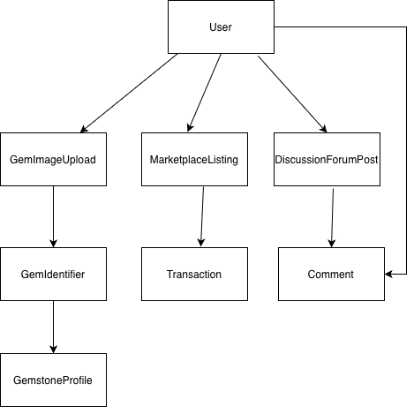
Figure 5 - Initial Class Diagram

24b Dynamic Modelling of Use Cases
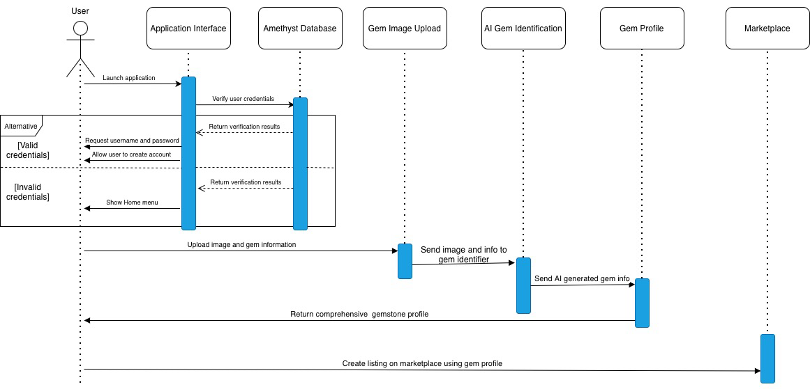
Figure 6 - Sequence diagram for when user uploads gem image, creates gem profile, and creates a marketplace listing

24c Proposed System Architecture
For project Amethyst, a ClientServer architecture integrated with MVC (Model-View- Controller) would be a good choice. The client side is what the user interacts with. This includes things like the application interface where users upload images, view gemstones, use the marketplace, and utilize the discussion forum. The server side handles things like operating the AI gemstone identification system, database storage, and user authentication and verification.
Furthermore, MVC would help organize the system into different parts. The Model would include classes like User, GemstoneProfile, DiscussionForumPost, MarketplaceListing, etc. The View is what the user sees and would include the application interface. The Controller would handle things like user login, and creating a post or comment. This setup would keep everything consistent and organized for the optimal user experience.

24d Initial Subsystem Decomposition
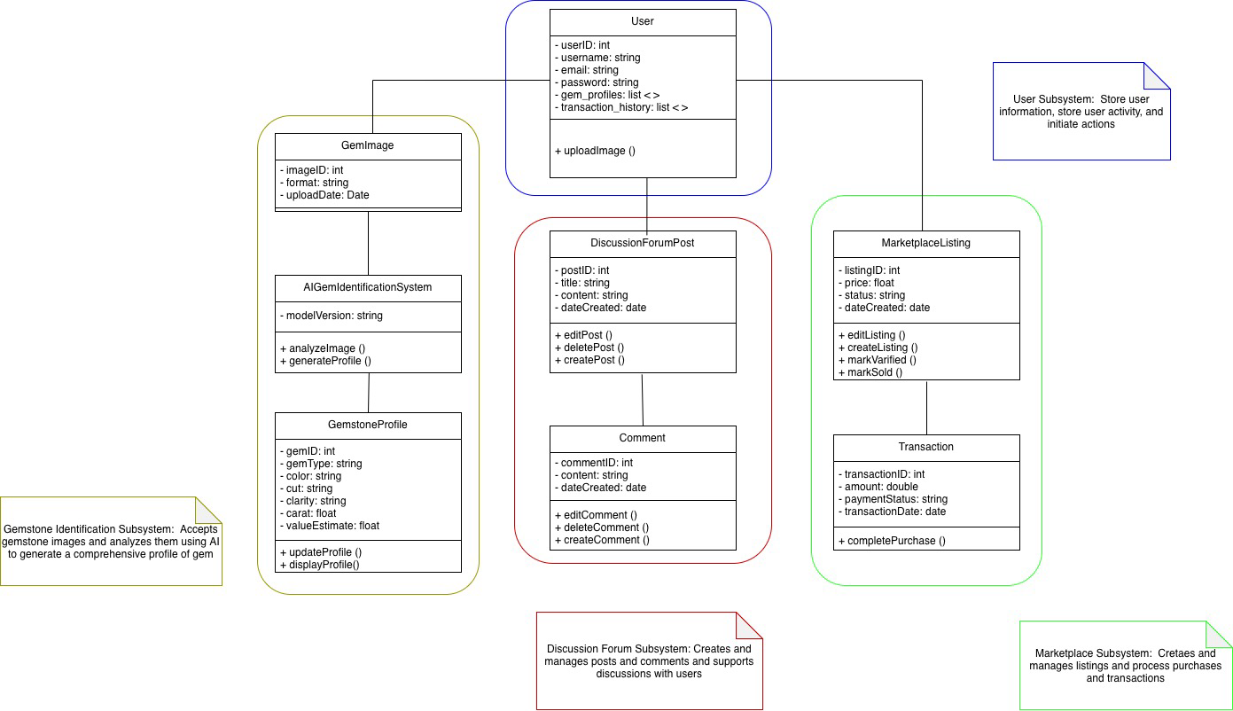
Figure 7 - Amethyst Initial Subsystem Decomposition

- Additional Design Considerations
25a Hardware / Software Mapping
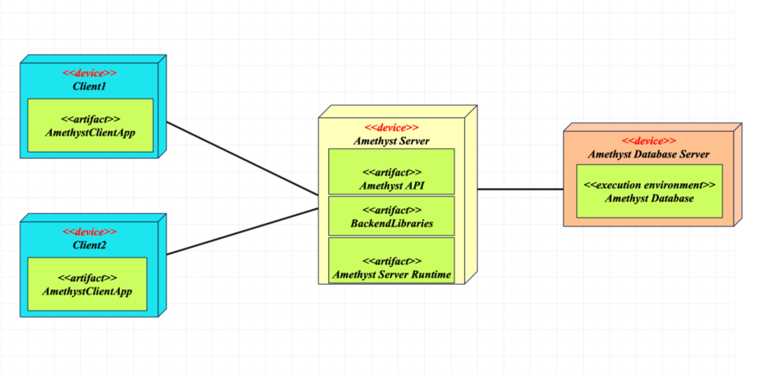

The deployment diagram shows how the main parts of Project Amethyst will be distributed across devices. The client devices will be our users running the application from their phones. These devices will send data to the AmethystServer which hosts the Amethyst API, and the server runtime that processes requests and manages communication between devices. The server is then connected to our Amethyst Database Server which stores and manages the application data.
25b Persistent Data Management
It is crucial for subsystems to have access to persistent stored data. For this, we will utilize a database system that saves important data and system information when the system shuts down or turns off. It will also be responsible for restoring data when the system comes back online. In this database, there will be classes such as GemStorage which stores all records and gem information, UIStorage which stores all information pertaining to the user interface, DiscussionForumStorage which stores all comments, posts, likes, downvotes, etc. present in the discussion forum subsystem, and MarketplaceStorage which stores all transaction and listing data.

25c Access Control and Security
In terms of access control, there will be different permissions for each account type. For a normal user, they will have the ability to access most functions and pages available publicly, including all main and personal pages. They can also make ID requests, create discussion posts, purchase items from the marketplace, and view the released catalogue, etc. These users will mostly have Read only permissions with some write and execute permissions on specific pages. Business users will have all of the same access control as regular users along with some added attributes. For example, business users can create listings on the marketplace for their items for sale. Additionally, they can create company groups that include their staff accounts, and oversee their marketplace page as a whole. These accounts will have to register with the Moderation Team under business with additional details and follow guidelines.
We also have trusted industry/field. These accounts are granted to certified and partnered experts in the field of gemology and/or mining that can assist in fact-checking and updating catalogue data. They are granted Read and Comment permissions to unreleased updates on the catalogue and for the public catalogue. They also have direct contact with moderation and development teams. Finally, we have the moderators. Moderation accounts have varying access permissions depending on their task, and these RWEs can change depending on grants by the manager of the teams. They are mainly designed to handle situations in the Marketplace and Discussions (for example, removal and account locks).

25d Global Software Control
The global software control for Project Amethyst will need to focus on coordinating systemwide services to ensure consistent operation across all subsystems. Since the app integrates gem identification, marketplace activity, discussion forums, and persistent storage, centralized control is needed to manage communication and system reliability. There needs to be a SystemController subsystem to act as the control room of the application. There will also need to be a RequestController to route data to its correct storage location. Finally there should be a BugLog subsystem that records errors to help with maintenance and bug fixing in a timely manner.

25e Boundary Conditions
Upon startup, Amethyst’s system will initialize database connections and validate system integrity before accepting any user input. Upon normal shutdown, all data is to be preserved and resources released to prevent data corruption. All processes will finish, all connections to the database will close, and internal management threads will close as well. Upon abnormal shutdown, the system will recover from any partial writes and roll back any incomplete transactions. Along with managing read/write permissions (discussed in 24c), the system’s configuration file management will also create any missing configuration files if need be.

25f User Interface
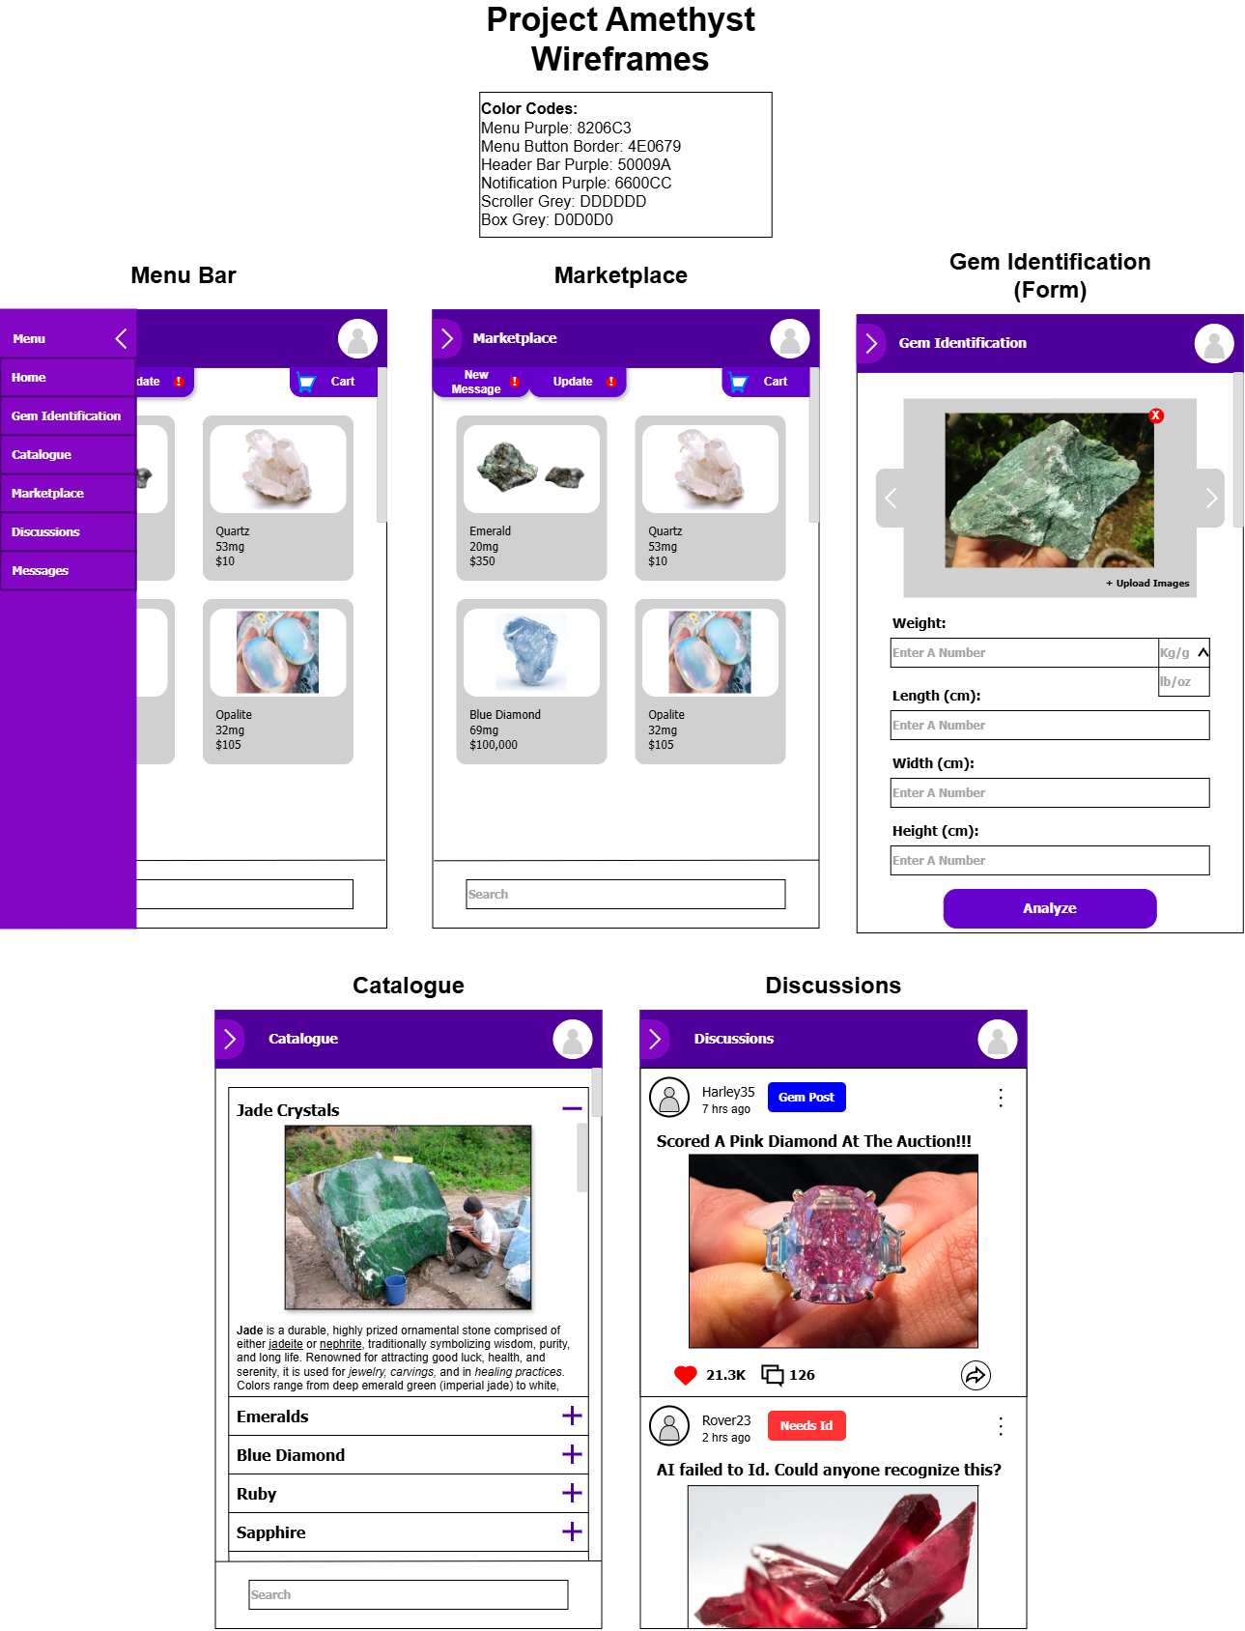
Figure 8 - Wireframes for Each Main Page of the Project
The user interface design of Project Amethyst focuses on following the standard layout and designs of existing applications with a similar purpose. For example, the Side-Menu-Bar is a common feature used across desktop and mobile applications, the Marketplace design was inspired by the layout of Amazon, Temu, and Ebay, and the Discussions page was inspired by the design seen in Reddit, Facebook, and Instagram. Other pages such as the Gem Identification and Catalogue pages focus on simplicity and intuitive design, which must allow users to have the idea of how to interact with them without needing outside assistance.

25g Application of Design Patterns
For Project Amethyst, there are no additional design patterns that need to be documented beyond the architectural choices already discussed in section 24c. The main design approaches, such as ClientServer and MVC, already cover the overall structure and organization of the system. At this stage of the design, no other specific software design patterns have been identified as necessary. If the system becomes more detailed later, patterns related to AI processing or database access could be considered, but they are not required in the current design.

- Final System Design
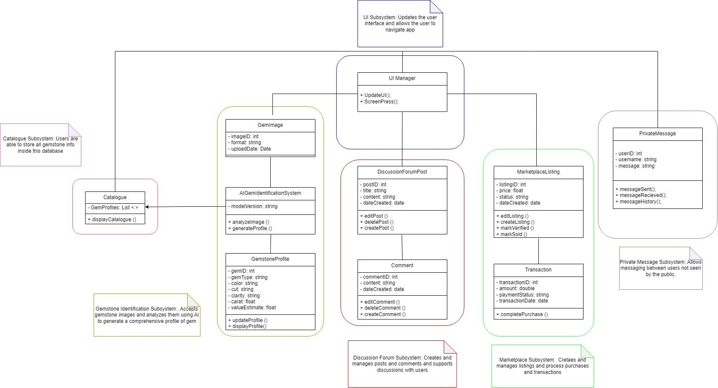
Figure 9 - Final System Design

- Object Design
27a Packages
- Private Messaging Package
- Market Place Package
- Discussion Forum Package
- User Interface Package
- Gem AI Package
- Catalogue Package

27b Subsystem I
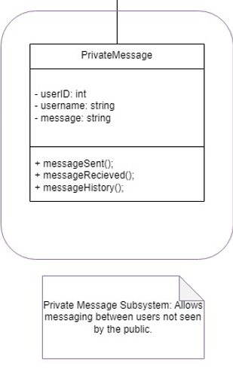
Figure 10 - Private Message Subsystem Class Diagram

27c Subsystem II
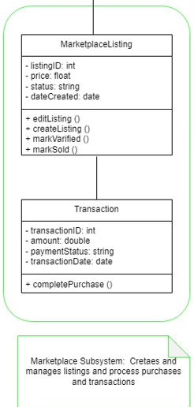
Figure 11 - Marketplace Subsystem Class Diagram

27d Subsystem III
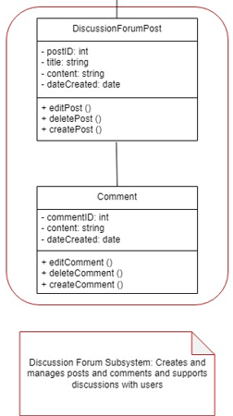
Figure 12 - Discussion Forum Subsystem Class Diagram

27e Subsystem IV
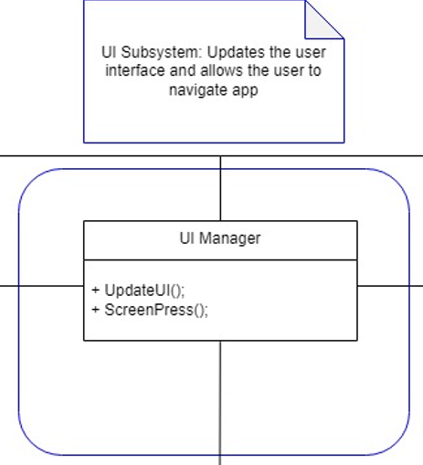
Figure 13 - UI Subsystem Class Diagram
27f Subsystem V
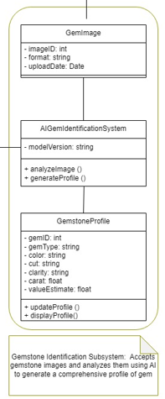
Figure 14 - Gem AI Subsystem Class Diagram
27g Subsystem VI
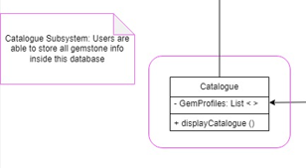
Figure 16- Catalogue Subsystem Class Diagram

IV Project Issues
- Open Issues
Scalability: The application would need to be supported by servers to handle back-end data and processes, particularly the components of the four major parts of the app (AI-Identification, Catalogue, Marketplace and Discussions). At the first few phases post-release, this could be handled mainly via cloud servers, and development/testing servers will be on physical servers with the development team. As coverage expands internationally, servers may be divided up in certain regions such as Asia, Europe, North America and so on so that access speeds are maintained at acceptable levels.
Regional Compliance and Localization: As coverage and use of the application spreads across states and other countries, legal requirements need to be evaluated and worked in following state/national laws of the regions. The same needs to be applied to adaptation and integration of regional languages and appropriate UI. Different regions may require special reworks/rebranding of the application to fit within these laws and cultural standards.
Standards and Laws: Laws and standards across countries, states and industries may change over time during the service life of this application. As such, adaptations need to be made to adhere to these changes via further updates and reworks. This applies but is not limited to data privacy, user interface norms and expectations, transactional processes, information security and integrity of the overall app.

- Off-the-Shelf Solutions
There exists separate applications in use today that cover major functions and parts of this application, but none compile everything this application offers into a singular app. Project Amethyst aims to do so to fulfill the needs of its consumers in the app, without having to download other separate applications to do so (which would consume more space and be a hassle for older users). However, this does not mean that Project Amethyst aims to replace these apps either, as they can coexist for the benefit of their users. An example of this would be a connection with Amazon where Project Amethyst filters non-gemstone related sellers out, and links customers to Amazon sellers quickly that handle the purchase, transaction and shipping of the products.

29a Ready-Made Products
The following applications exist and are widely used by the public as of writing this. These applications can be used alongside Project Amethyst should the need arise:
- Wikipedia (or online gemstone encyclopedias)
The sections of the Catalogue have a space constraint, and thus may only be able to display roughly 2-3 paragraphs maximum each to conserve space for other sections. This means for the full details and in-depth information behind each section, links to respective Wikipedia or other only gemstone encyclopedia pages may be linked within each catalogue section for the use of interested users. This will also save on space requirements to handle the catalogue, and makes the best use out of both applications.
- Amazon (and other online stores)
The Marketplace part of the application is a great place to find dedicated gemstone sellers and their offerings, as the application does focus on gemstones only as a product. However, Amazon may be a better application in terms of transactions, shipping and handling of packages as that is the focus of their business. As such, it is expected that sellers may link their Amazon pages on the Marketplace, and handle the order there rather than Marketplace. In this way, users can use the Project Amethyst Marketplace to automatically filter for well-known gemstone sellers, and then transfer to the Amazon pages of the sellers for purchase.
- r/Gemstones on Reddit
The r/Gemstones subreddit is a version of what the Discussions page on Project Amethyst should emulate. While Reddit itself is much larger than this part of the project, this particular subreddit and the Discussion page share similar function, with the addition on Project Amethyst being it tags certified field experts in gemology, so users will be able to distinguish between posts and comments made by them apart from regular users. This way, the Project Amethyst Discussion page is more trustworthy for solid facts.
- Social Media (Instagram, Facebook, Twitter)
Similarly to existing social media, the Discussion page functions as a place to share finds among the community. However, Project Amethyst only targets groups interested in gemstones, crystals and other minerals compared to social media that is open to everyone. As such, it will not directly compete with such existing platforms, but rather knit together the gemstone community in a similar fashion.

29b Reusable Components
- NumPy & Python for AI-Identification
NumPy is a library commonly used in machine learning and data science programs, and can be useful particularly in the creation of the AI-Identification software for the Gemstones. Its particular code will be expected to be created in Python, connecting to other files and programs in the application only for input and output of information. Other similar libraries such as TensorFlow and PyTorch may be used too depending on the preference of the team in charge of creating the AI-Identification program.
- SQL & SQL Server Management Studio
Information on gemstones for display on the Catalogue and access by the AI-Identification may be stored in a SQL database, and managed through software such as SQL Server Management Studio. Specific queries to extract and load information can be coded on the backend and be called upon by the two connected softwares when needed.

29c Products That Can Be Copied
To keep user experience intuitive, common app structures should be copied by the respective pages on Project Amethyst. This means the Marketplace should follow common design layouts and functions utilized by apps such as Amazon, Temu, and Ebay in terms of display, cart, and information structure for products. For the Discussions page, it should follow design decisions seen in apps such as Reddit, Facebook, and Instagram such as the layout of postings, comments structure, the “verified” status, as well as likes and shares.

- New Problems
30a Effects On The Current Environment
- Miners and the Mining Industry
The mining industry and its workers may use Project Amethyst's AI-Identification software as a means to quickly and conveniently identify potential gemstones and mineral sites and discoveries. There is also potential for similar software to be embedded on processing sites as a means to identify and separate ores and minerals into respective collections (similar to airport luggage processing systems). However, this may not work underground where there is no signal to the networks the system relies on.
- Gemstone Sellers
Sellers may use the platform as a means of selling and advertising their businesses to potential buyers within the gemstone community. They are able to list items for sale on the Marketplace, and advertise their products within the Discussion forum. In a way, this functions similarly to Facebook and Facebook Marketplace in the same manner.

30b Effects On The Installed Systems
Because of the reliance on external servers separate from user devices, performance, storage space, and battery life is not expected to be a problem for users using the website. However, depending on how the AI-Identification is implemented, if a local version is made available that is installed on user devices, it may diminish the processing performance for a short period of time, as well as drain battery faster when used due to the AI having to perform its duties on mobile platform hardware. Similarly, depending on decisions made during the design and implementation of the Catalogue, if a local version is to be made and installed on user devices, this is expected to consume much more storage space.

30c Potential User Problems
- Risk of Misinformation
As the main features of this application rely on AI and human processing to share information with users directly, there is a chance that misinformation is spread whether intentionally or unintentionally. The gemstone identification relies on the confidence of the AI’s accuracy and ability to predict the correct gemstone given enough information, but it is still a prediction and cannot guarantee 100% correct identification all the time. For the Catalogue and Discussion pages that involve human sharing of information, mistakes can be made and missed, or even beliefs that may not be true are spread. This is the risk of community-driven platforms, and must be mitigated by both the Moderation Team, as well as public support in reporting such errors.
- Risk of Scams
Like all social media and online shopping platforms, the Marketplace and Discussions page can very well be subject to the spread of scams, whether through false links, false sales listings, and general false information spread by users. While it is impossible to vet each user completely, the Moderation Team can mitigate this risk by analyzing links before releasing publicly, verifying business users on application, and monitoring reports. Users can help by reporting malicious activity to the Moderation Team and sharing alerts with other users.

30d Limitations in the Anticipated Implementation Environment That
May Inhibit the New Product
This project involves software only on the user’s end, so there are not many issues that could arise for them. To use the application, it is given that they must at the very least have access to a camera and/or gallery of images for the AI-Identification, as well as internet connection. Given the limitation of local device processing power and storage, the AI-Identification tool in particular may operate on a diminished performance (speed and accuracy) as it will have to rely on a locally stored database, or not at all (depending on implementation). There will also not be access to the Catalogue, Marketplace and Discussion pages without internet as these systems rely on separate servers.

30e Follow-Up Problems
Unforeseen issues in the structure, application of the design, integrity of data, and others may arise only during the development, testing, or release of the application as a whole. These may only be exposed through the active production and use of parts of the software and their specifics may not be estimated as of writing this document. The development and maintenance teams are expected to hold responsibility for such issues by further communication with users, planning of resolutions and updating to resolve these problems. These should also be documented alongside.

- Migration to the New Product
Not Applicable

- Risks
- AI-Identification Failure
The main reason this project exists revolves around the AI-Identification system that should be able to quickly identify a gemstone, or at least give possibilities given images and its metrics within an acceptable level of accuracy. This is possible but requires machine learning techniques and image analysis that may not be skills present in lower-level programmers. It would take a team that includes experienced machine learning programmers and data scientists to program, test, and manage the tool and achieve what Project Amethyst set out to do. Failure to do so may cause the project to lose value in the community.
- Failure to Partner with the Gemology and Mining Industry for Fact Checking and Moderation Assistance of Facts
The fields of Gemology and Mining carry valuable skills, knowledge and experience that are not available in the development team alone. Gaining partnerships and connections with experts in the field will be valuable towards understanding and creating a product that is useful to all people whether for hobby or work. Partners can also provide support in fact-checking the project’s data on gems, testing and reworking its AI-Identification system, and updating with any new discoveries. They also give a stamp-of-approval that Project Amethyst can be trusted by the non-expert users. Without these, Project Amethyst will not be as capable, nor trustworthy to the community.
- Failure to Promote the Project to the Gemstone Community
Although the project has components that are already familiar to most people with a smartphone, being a new all-in-one application of its type means it requires promotion to the gemstone community in order to be used. These can be in the form of advertisements, cooperation with gemology and mining experts to share, and sharing early versions of the final product for alpha testing and community feedback. Without these, Project Amethyst may go unnoticed and be buried under thousands of other applications in the market.

- Costs
The development of Project Amethyst involves costs across three phases: Development, Launch, and Maintenance. These estimates account for the multi-component nature of the platform, AI Identification, Catalogue, Marketplace, and Discussion Forum each requiring dedicated engineering effort.
Development Phase
The largest cost driver is software development. Because Amethyst spans a mobile frontend (iOS), a web backend, a SQL Server database, and a custom AI gem identification model, the team required spanning frontend engineers, backend engineers, data scientists/ML engineers. Building and training the AI model in particular requires experienced machine learning practitioners and a curated, verified gemstone image dataset, which may need to be licensed or assembled from scratch, a significant hidden cost.
Task | Team Size | Time Estimate | Estimated Cost
Gemstone AI research | 2-4 people | 3-5 months | $30k-$80k
AI model development & training | 3-5 people | 4-6 months | $60k-$120k
Backend API development | 3-5 people | 5-8 months | $90k – $160k
Mobile app development | 3-6 people | 5-8 months | $100k – $200k
Database design & implementation | 1-2 people | 2-3 months | $20k – $40k
Marketplace & payment integration | 2-3 people | 3-4 months | $30k – $60k
Discussion forum development | 1-3 people | 2-3 months | $15k – $30k
UI/UX research and design​​ | 2-3 people | 3-4 months | $30k – $60k
QA and integration testing | 2-4 people | 3-5 months | $30k – $70k
Development subtotal |  | 12-24 months | $405k-$820k
Given the initial budget constraint of approximately $300,000 USD stated in section 6g, the team should plan to scope the first release conservatively, prioritizing the AI Identification and Marketplace components, with the Discussion Forum added in a subsequent release. A phased approach reduces financial risk while still delivering core value to users.
Launch Phase
Task | Team Size | Time Estimate | Estimated Cost
App Store submission | 1-2 people | 1 month | $5k-$10k
Marketing & outreach | 2-3 people | 3-6 months | $20k-$50k
Industry partner outreach | 1-2 people | ongoing | $10k-$20k
Launch Subtotal |  |  | $35k-$80k
Ongoing Maintenance
Task | Team Size | Estimated Cost
Cloud server hosting | 1-2 people | $5k-$10k
AI model updates and retaining | 1-2 people | $5k-$10k
Bug fixes, patches, and feature updates | 2-4 people | $15k-$30k
Moderation team | 2-4 people | $10k-$20k
Maintenance subtotal |  | $33k-$88k
Table 5 - Project Cost Estimate Table
Non-Financial Costs
Beyond dollars, the project carries significant time and opportunity costs. Building a reliable AI gemstone identification system is a research-intensive undertaking with no guaranteed timeline. Each month spent iterating on model accuracy is a month that competitors could enter the space. Finally, establishing trust with the gemology industry necessary for expert partnerships and catalogue credibility takes relationship-building time that cannot be purchased directly.

- Waiting Room
The following features were discussed or implied during requirements development but will not be included in the initial release of Amethyst. They are ranked by estimated user impact and feasibility for a future update.
Rank 1:
Offline AI Identification (Limited Local Model)
A locally installed, reduced-accuracy version of the gemstone identification AI that functions without an internet connection. This would serve users in the field miners who may operate without reliable network access. The local model would reference a smaller, cached set of the Catalogue and display a disclaimer that results are limited compared to the full cloud-based analysis. This feature is not a priority for the initial release because the local database and model size requirements make it a significant additional engineering effort, but it addresses a clear gap for the core user group.
Rank 2:
Auction / Bidding System for Marketplace
While the requirements mention "bidding" as a listing format, a fully developed real-time auction system with countdown timers, live bid tracking, and automated closing logic is delayed to a future release. The initial Marketplace will support fixed-price listings and a basic bid submission mechanism. A proper auction system requires additional payment integration complexity and moderation infrastructure to prevent bid manipulation.
Rank 3:
Mobile AR Gem Scanning
An augmented reality mode allows users to point their phone camera at a gemstone in real time and receive an overlay of identification information without uploading a static photo. This requires significant additional computer vision engineering beyond the current image-upload model and is left for a future major version.
Rank 4:
Social Collection Sharing and Profiles
Enhanced public user profiles where collectors can display their gem collections, follow other users, and receive activity feeds of notable finds in the community. This expands the Discussion Forum's social dimension into a more structured collector network, similar to what platforms like Discogs provide for record collectors.

- Ideas for Solutions
The following are suggestions for the development and testing phases that follow this design document. They are offered as starting points rather than mandates.
AI Identification Model
Rather than building a gemstone classification model entirely from scratch, the team should investigate transfer learning from existing large image classification models such as ResNet or EfficientNet, fine-tuned on a gemstone-specific dataset. Libraries such as PyTorch or TensorFlow provide the tooling for this, and pre-trained weights on ImageNet give the model a strong visual feature foundation before it ever sees a gemstone image. For the dataset, the team should contact gemological institutions such as the GIA and explore publicly available mineral image datasets to supplement any images collected internally. Model confidence scoring can be implemented using softmax output probabilities, with a calibrated threshold (example 80%) determining whether the system presents a result or redirects the user to the Discussion Forum.
Backend and API
The .NET backend should expose a clean RESTful API with versioned endpoints from the start, so that future mobile and web clients can evolve independently without breaking changes. Swagger/OpenAPI documentation should be generated automatically from the codebase. For the AI integration endpoint specifically, consider an asynchronous job queue pattern so that image analysis requests do not block the API thread while the model processes the input.
Database
SQL Server with Entity Framework Core is a reasonable choice given the mandated stack. The team should invest early in proper indexing strategy, particularly on gem_Type, listing_Status, and user_ID fields, which will be the most frequent filter and join targets. For the Discussion Forum post storage, consider a soft-delete pattern (adding a deleted_at timestamp rather than physically removing rows) so that moderation actions remain auditable without data loss.
Testing Strategy
Given the AI component, standard unit and integration testing must be supplemented with model evaluation pipelines. The team should maintain a held-out test set of verified gemstone images, completely separate from training data, and track accuracy metrics (top-1 and top-5 identification accuracy, valuation MAPE) across every model version. This gives the QA team quantitative regression tests for the AI component analogous to how unit tests protect the application logic.
Payment Integration
Shopify Payments or Stripe are both reasonable choices for the initial marketplace. Stripe in particular offers well-documented APIs, strong sandbox testing environments, and straightforward PCI DSS compliance paths. The team should prototype the payment flow in Stripe's test mode before committing to the full integration, and should handle webhook events to keep transaction state consistent between Stripe and the Amethyst database.

- Project Retrospective
What Worked Well:
- Weekly Scrum meetings and writing reports let each team member know what has been accomplished, what needs testing/review to be done by others, and who is tasked with what for the next period. It also allowed members to request help or clarification from others on parts they may be stuck on.
- Separation of tasks into clear-cut sections for each team member allowed for easier tracking of what each person needs to complete. This means work is separated into whole chunks rather than any mixed mash of tasks scattered throughout the section.
- The usage of draw.io was particularly helpful in easily designing the report’s various diagrams, and allowed for accurate colouring and scaling of each aspect of the wireframes (Figure 8). This makes it easier to convey accurate details and vision to following teams that use this document in development.
What Did Not Work Well:
- Estimating unknowns such as cost, scaling requirements (how many servers needed), and true development time requirements proves hard to accurately estimate as it is dependent on how many people would be developing the application. Because the software can be broken down into its 5 main components (Gem Identification, Catalogue, Marketplace, Discussions, Menu), it can easily be split up to be handled by separate teams, but the time needed is dependent on the manpower present.
- Specifics on the laws and regulations will require consultation from the field to ensure that the application is compliant. In addition, parts of the project deal with different public space types, and different regulations may apply. As such, specifics could not be incorporated into this report.
Recommendations For Improvement:
- Coordination and collaboration with the actual development team would allow for more accurate estimations on time and resources needed for the project.
- Having a dedicated Scrum Master to manage the Jira software and coordinate between the development and design teams would allow for a more refined process and final product of both the application and accompanying documentation and reports.

V Glossary
Analyze - The act of breaking down input information into parts that can be attributed to certain patterns, to be compared to data from the catalogue. (For example, colour RGB, density, location).
Moderation - The act and involvement of regulating user activities in the application, particularly across shared public spaces to ensure the safety of users and the application itself.
Partner - In terms of people, the assistance of those who would lend their expertise to help ensure the integrity of Project Amethyst. In terms of separate applications and structures, those that are their own object of use, but the pairing with Project Amethyst compliments both, and connection through off-application links (For example, Marketplace - Amazon).

VI References / Bibliography
[1] | Visual Paradigm. “What Is Sequence Diagram?” Visual-Paradigm.com, 2019, www.visual-paradigm.com/guide/uml-unified-modeling-language/what-is-sequence-diagram/. Accessed 18 Apr. 2026.
[2] | Fakhroutdinov, Kirill . “Examples of UML Diagrams - Use Case, Class, Component, Package, Activity, Sequence Diagrams, Etc.” Www.uml-Diagrams.org, www.uml-diagrams.org/index-examples.html.
[3] | Fowler, Martin. Praise for UML Distilled. 2003.

VII Index
Analyze 6, 12, 29, 34, 35, 37, 38, 39, 41, 97, 98
Moderation 50, 54, 55, 56, 57, 61, 65, 75, 94, 95, 97
Partner 9, 11, 20, 21, 22, 60, 77, 95, 97

